  
 **CSE231  
 SEC: 06  
  
 Project**   
 Seven-Segment Display Using Sequential Circuit  
 on  
 BABAFAFA  
  
 **Submitted to:** Dr Mohammad Monirujjaman Khan  
  
  
 **Group Members:**  
 1. Kazi Mahbub Jamil 1921626042  
 2. Mahinur Sazib Sristy 192105504

3. Md. Sihab Bhuiyan 1912403642  
 4. Md. Adib Sadman 1921050042  
  
  
 **Written By :**  
 Kazi Mahbub Jamil  
  
  
   
 **Date:** 22 Jan,2021  
  
  
 Table of Content:  
1. Introduction  
2. Encoder & Decoder  
3. Seven-Segment Display  
4. About 555 Timer

5. How 555 Timer Works

6. Asynchronous & Synchronous circuit

7. Reason behind choosing Asynchronous circuit  
8. Truth Table  
9. Derived Equation using SOP

10. K-map & Circuit Diagram  
11. Sequential circuit

12. Logisim

13. Conclusion  
  
  
  
  
  
  
  
  
  
  
  
  
  
  
  
  
  
  
  
  
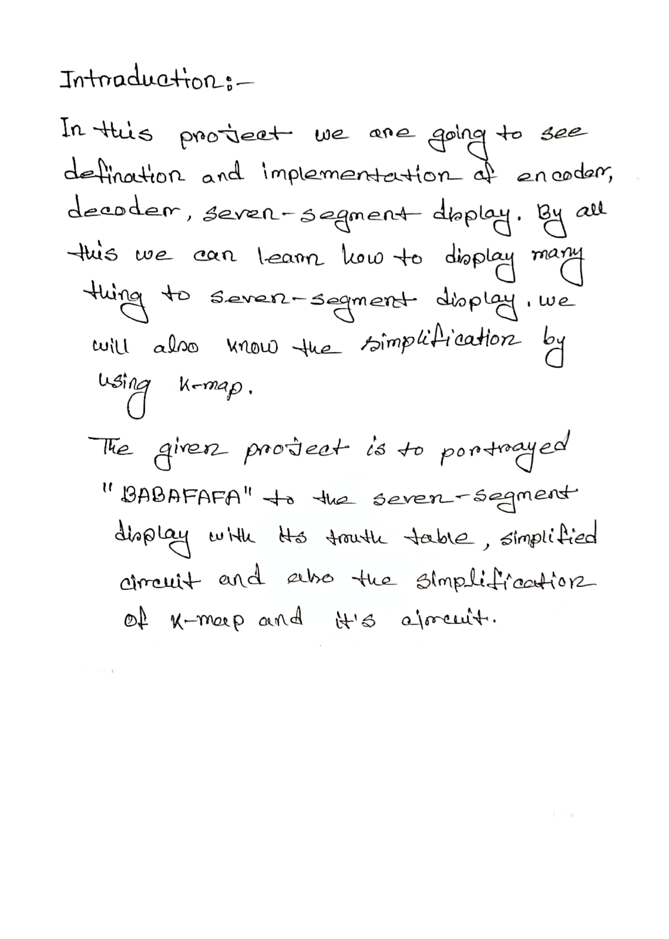  
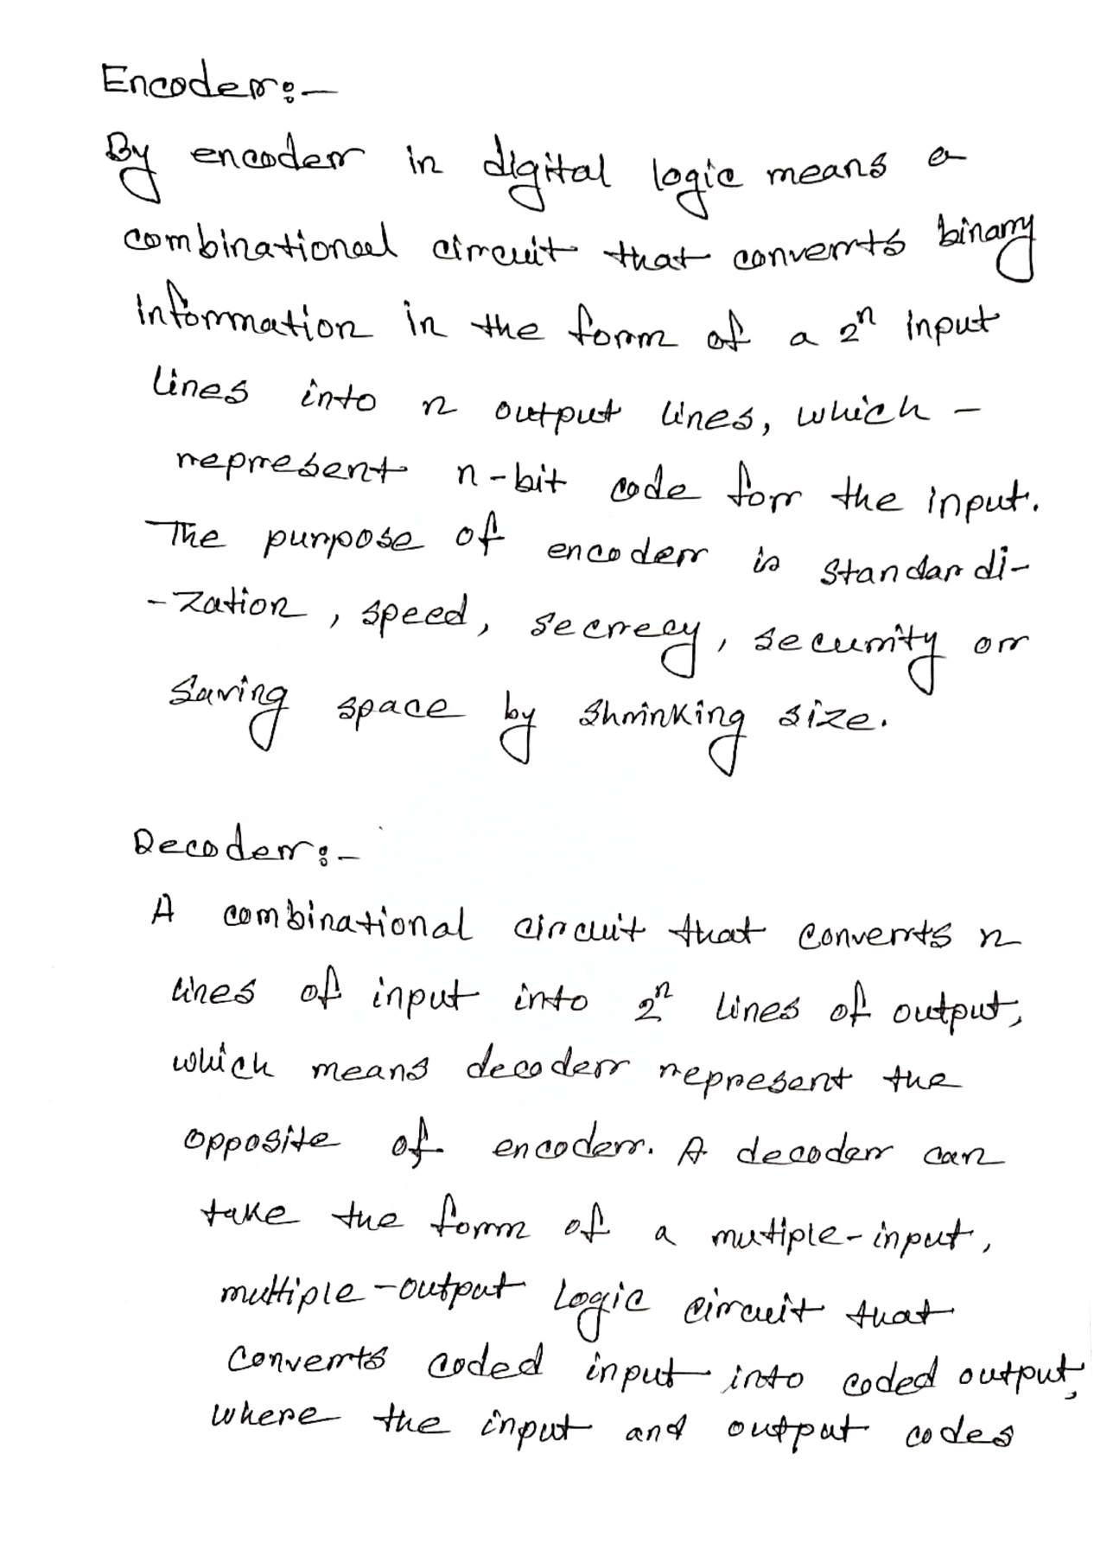  
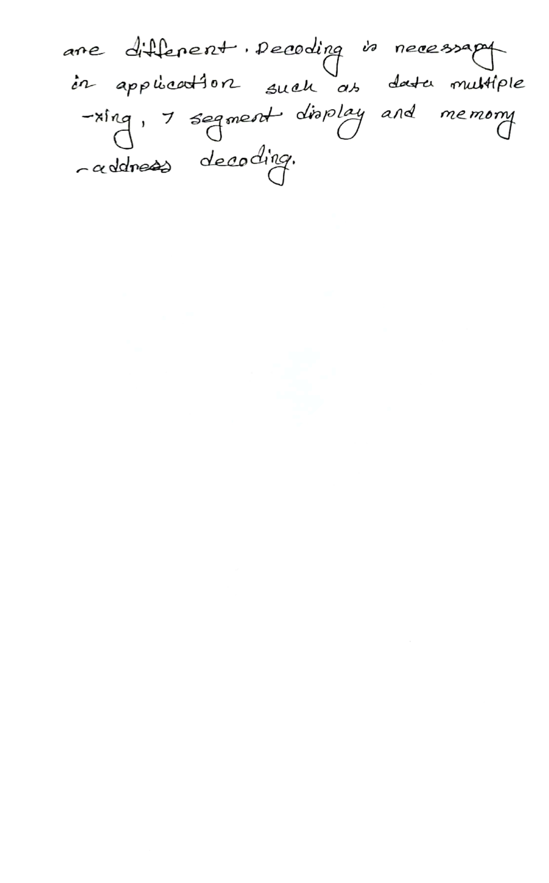

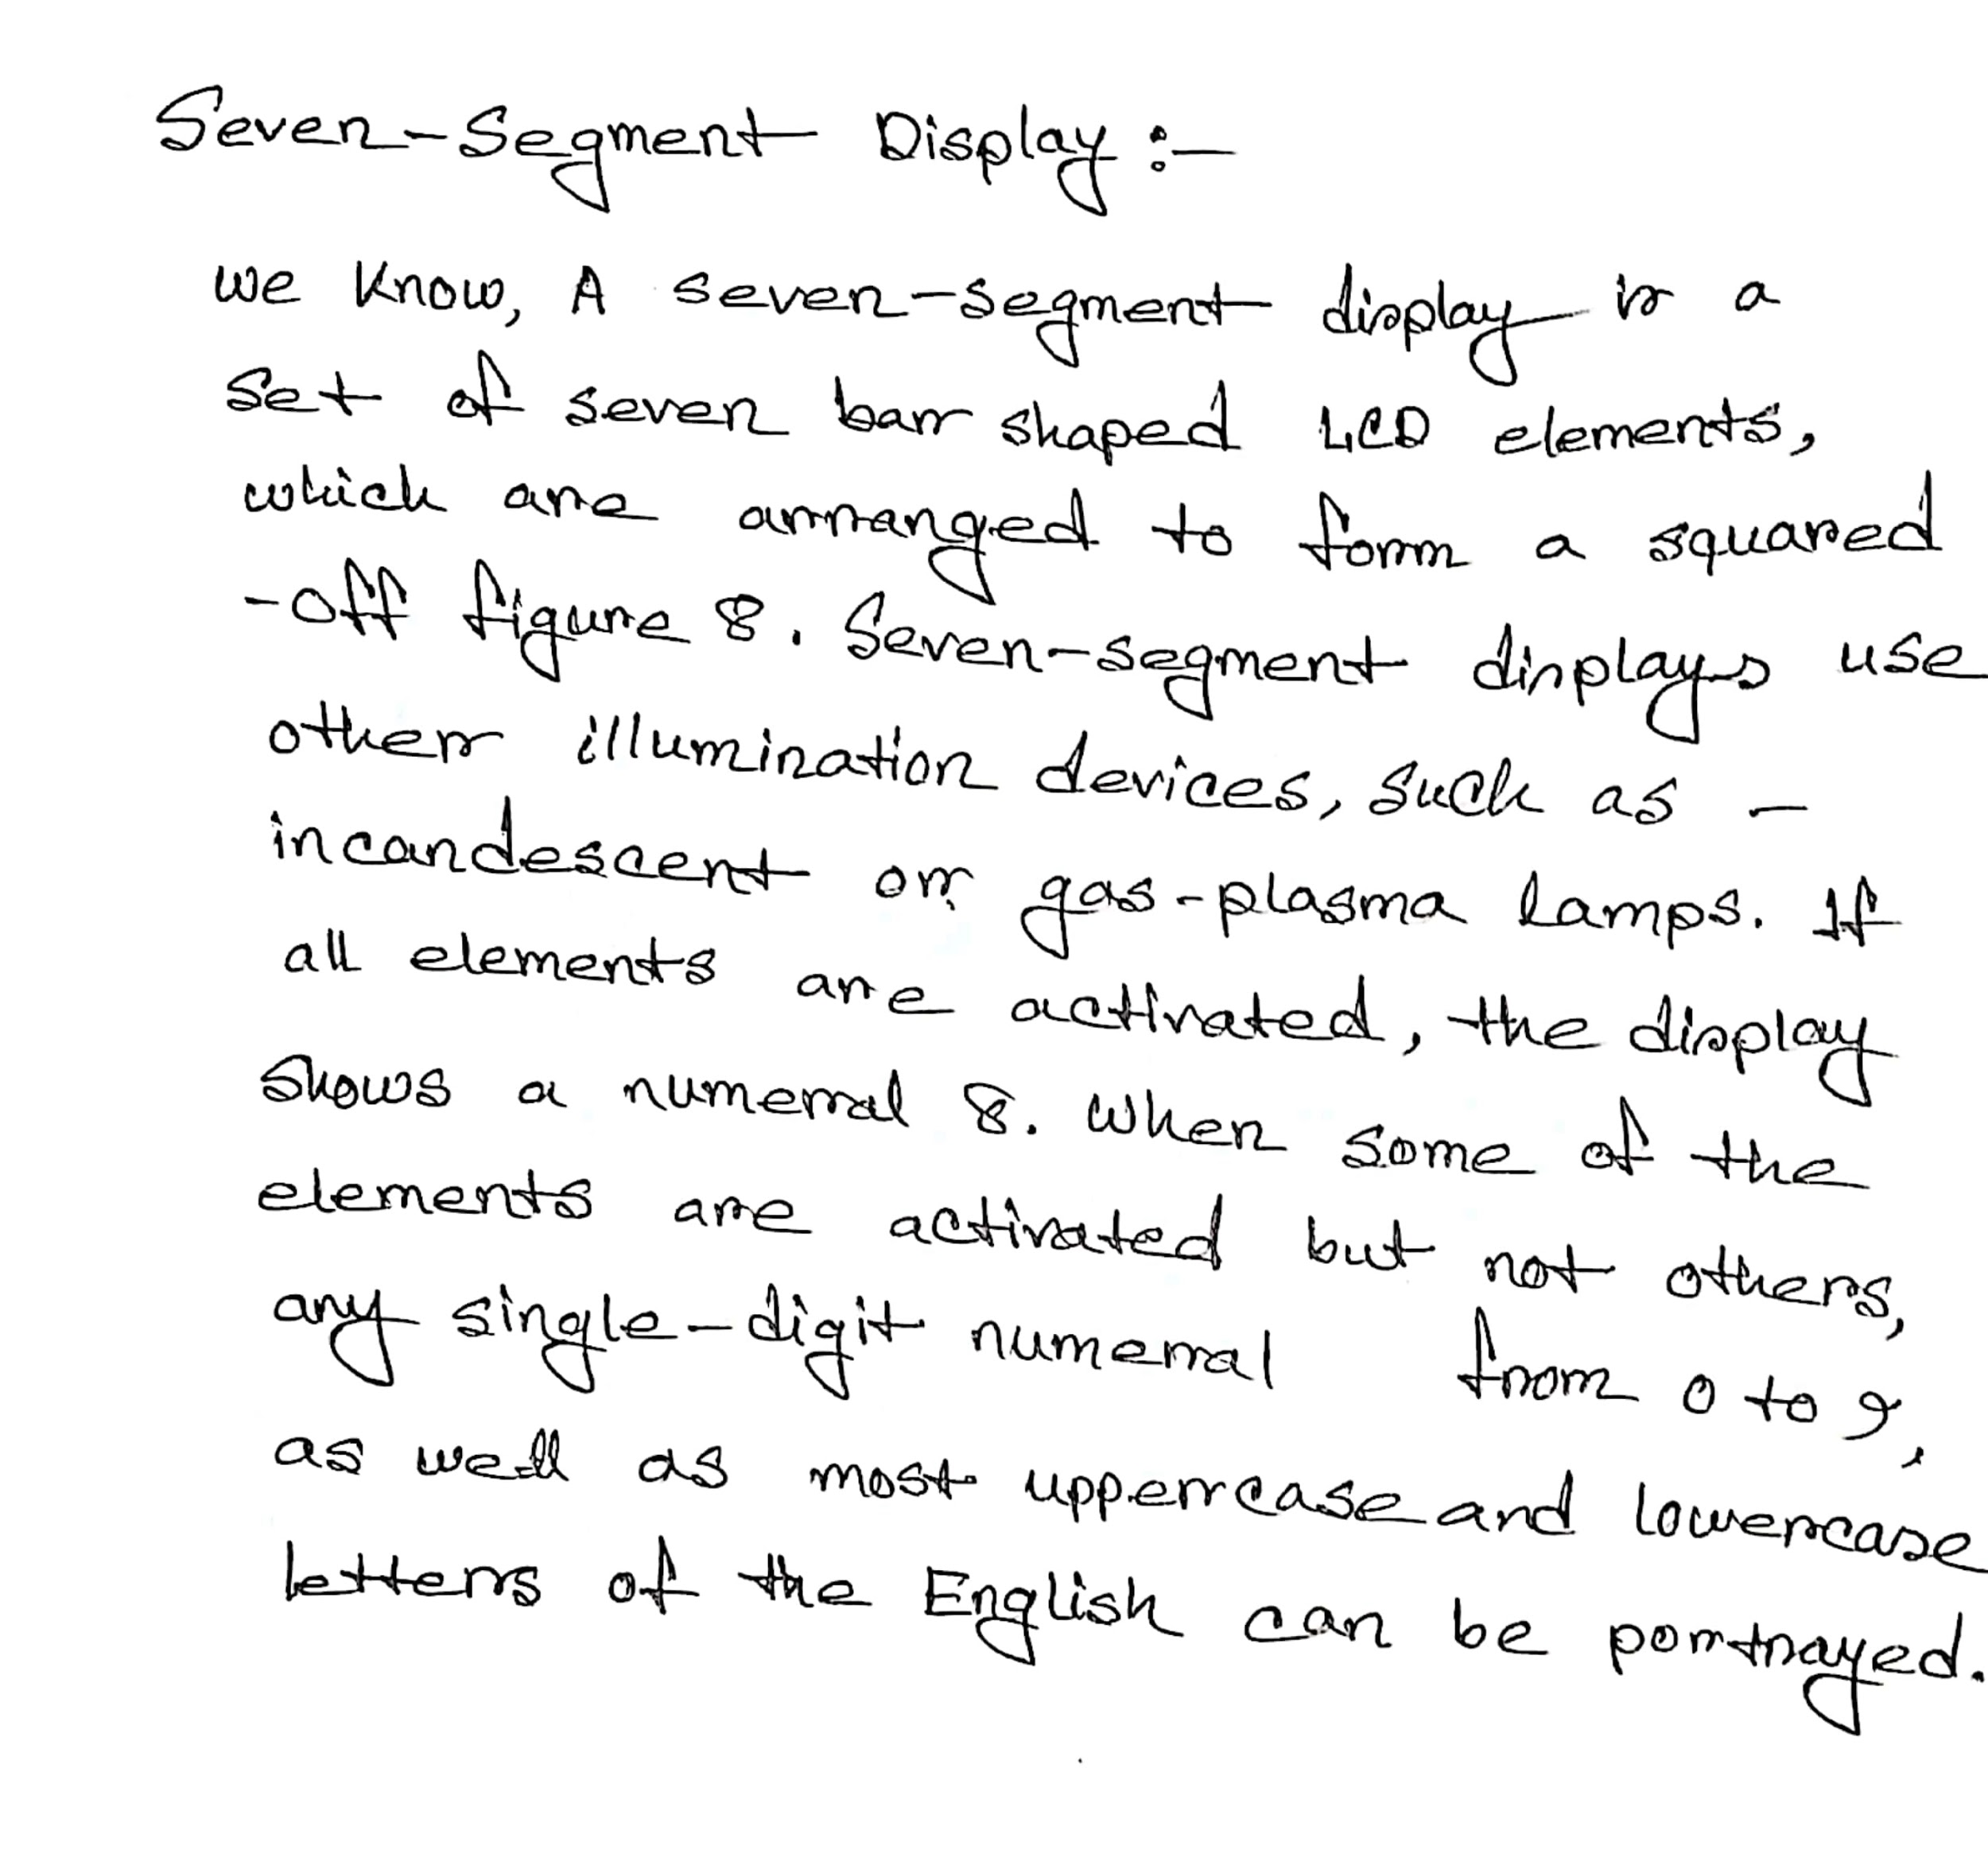

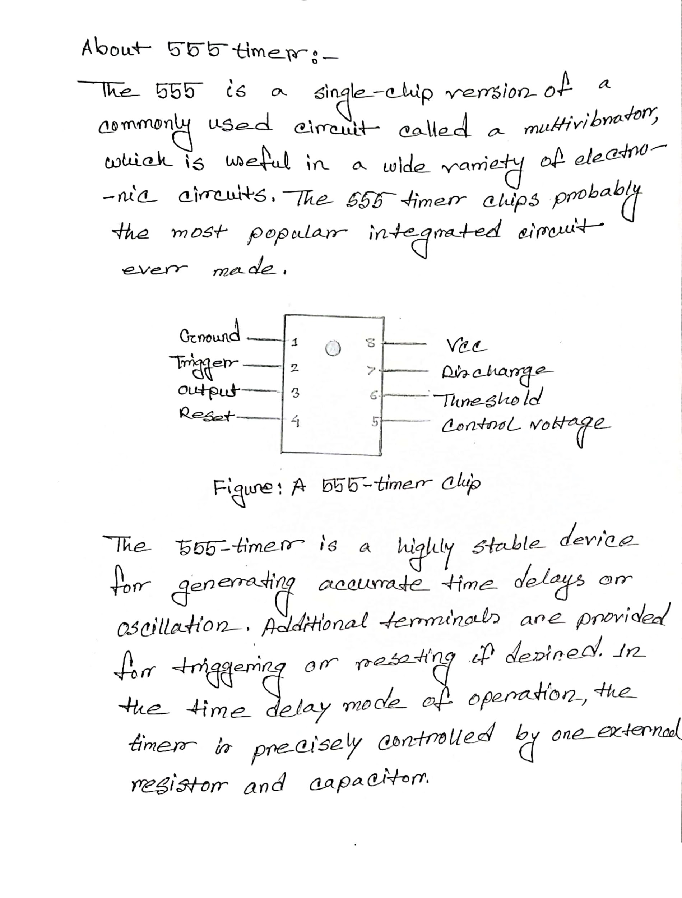

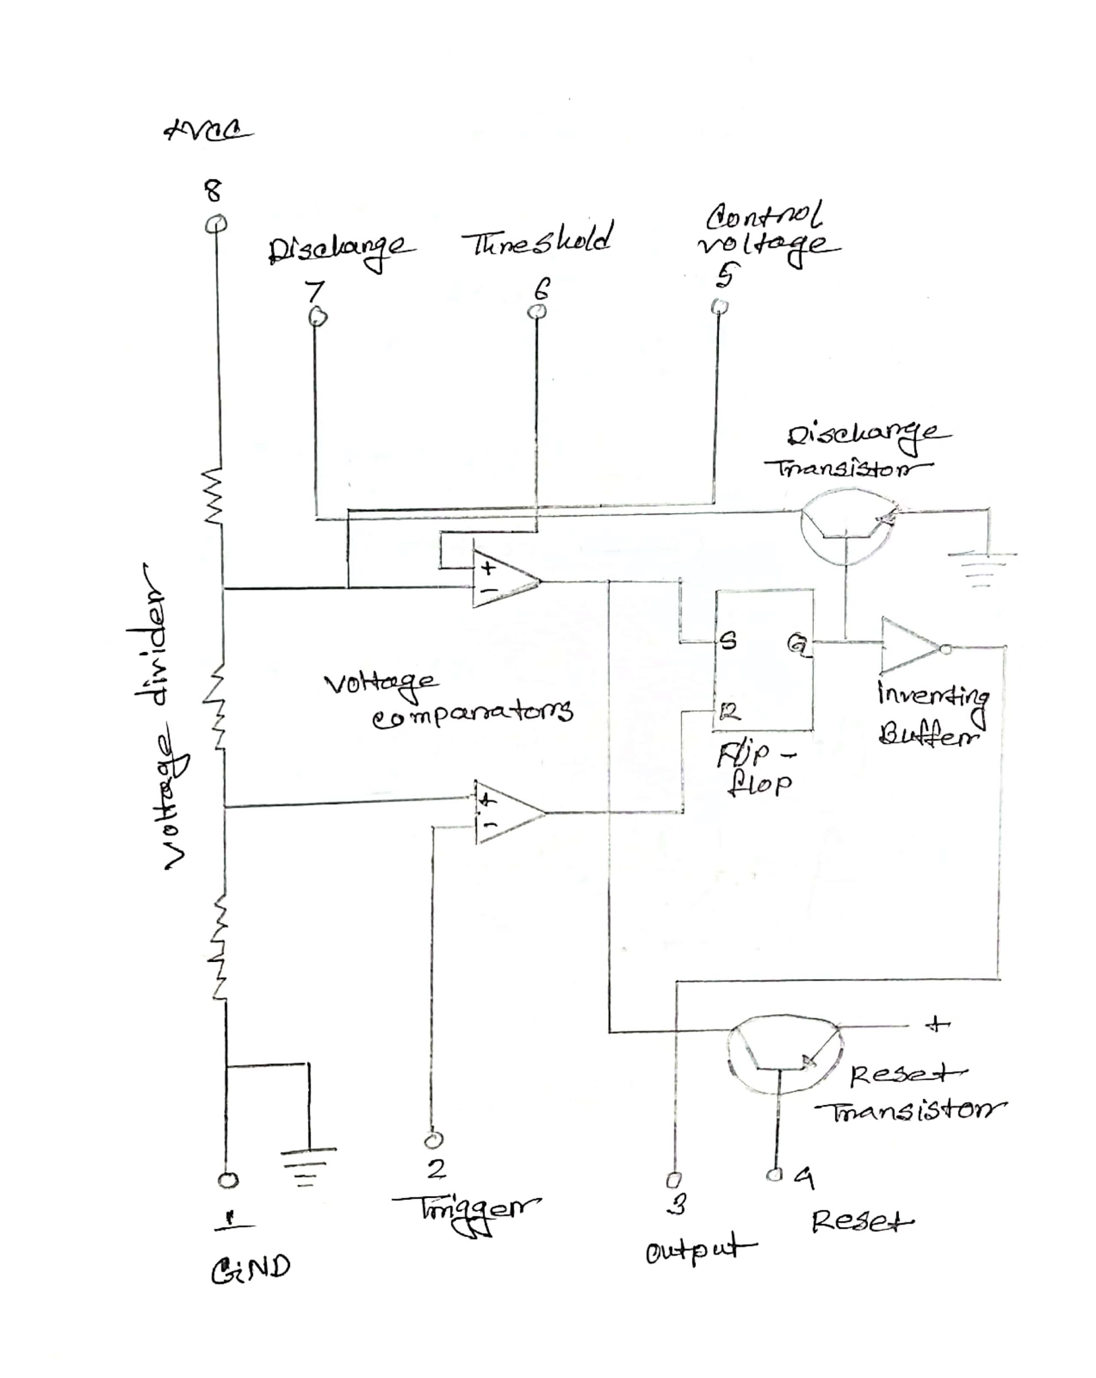  
**Figure: Internal Construction Of 555 Timer**

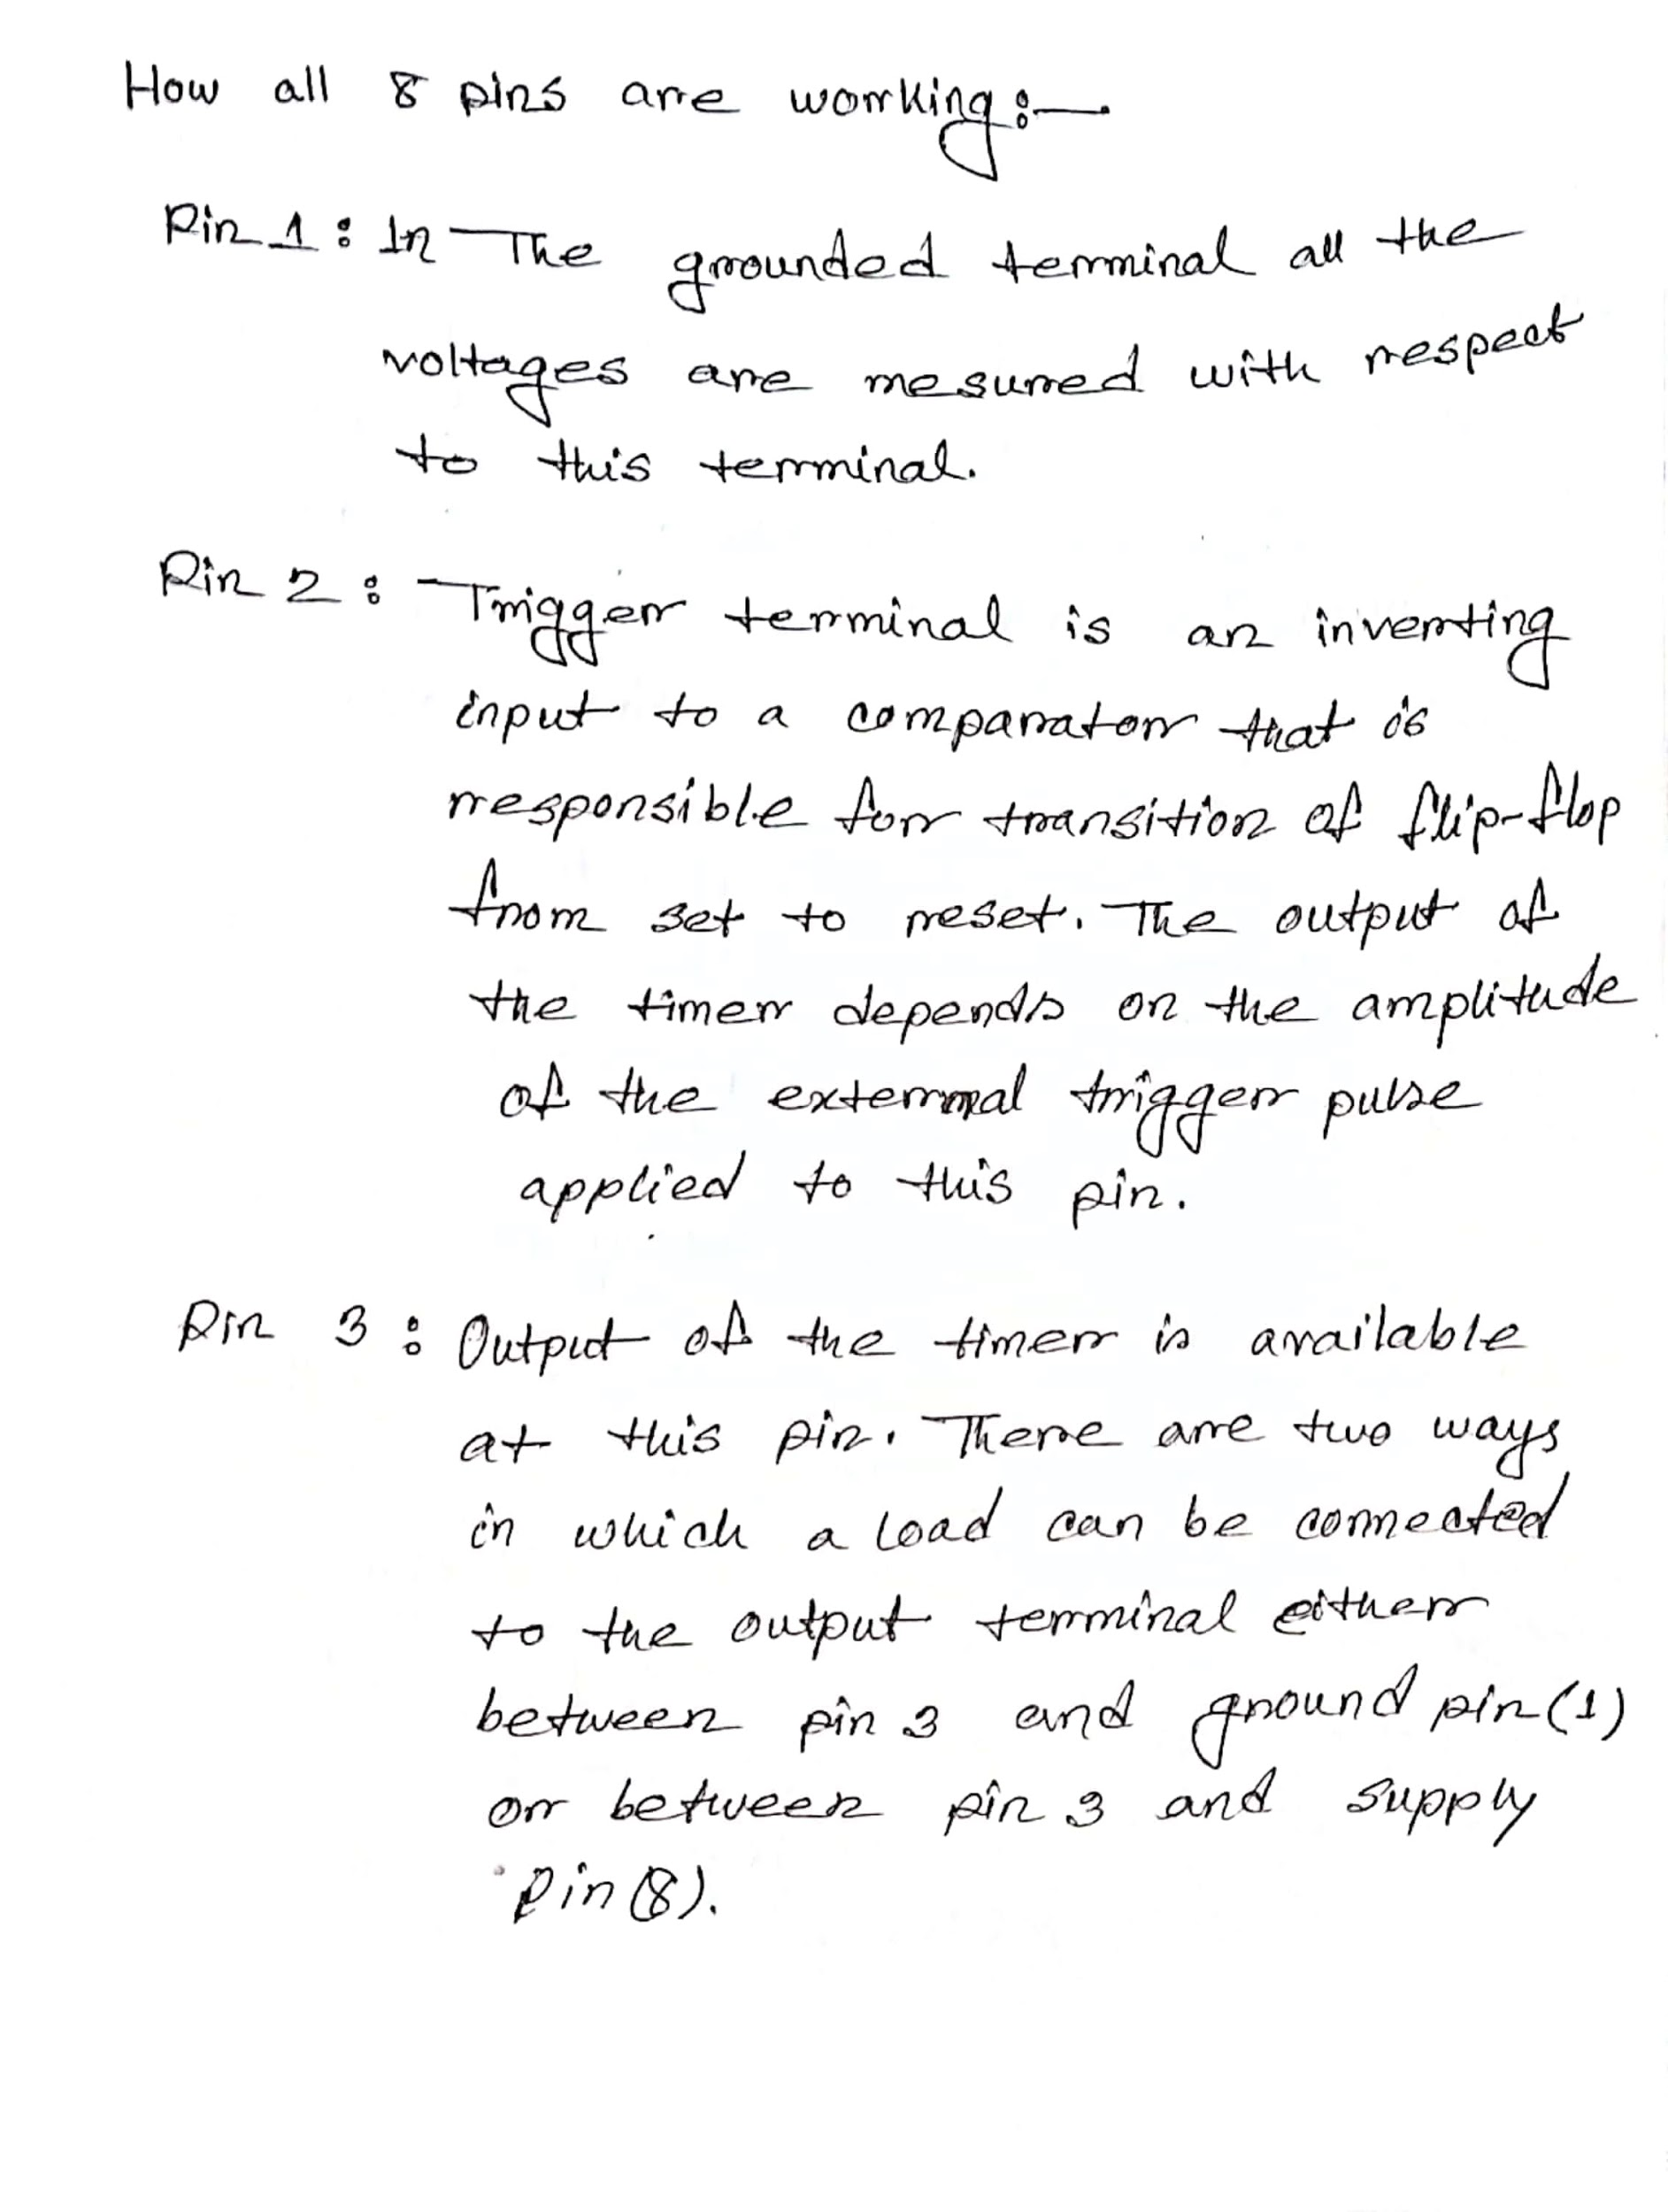

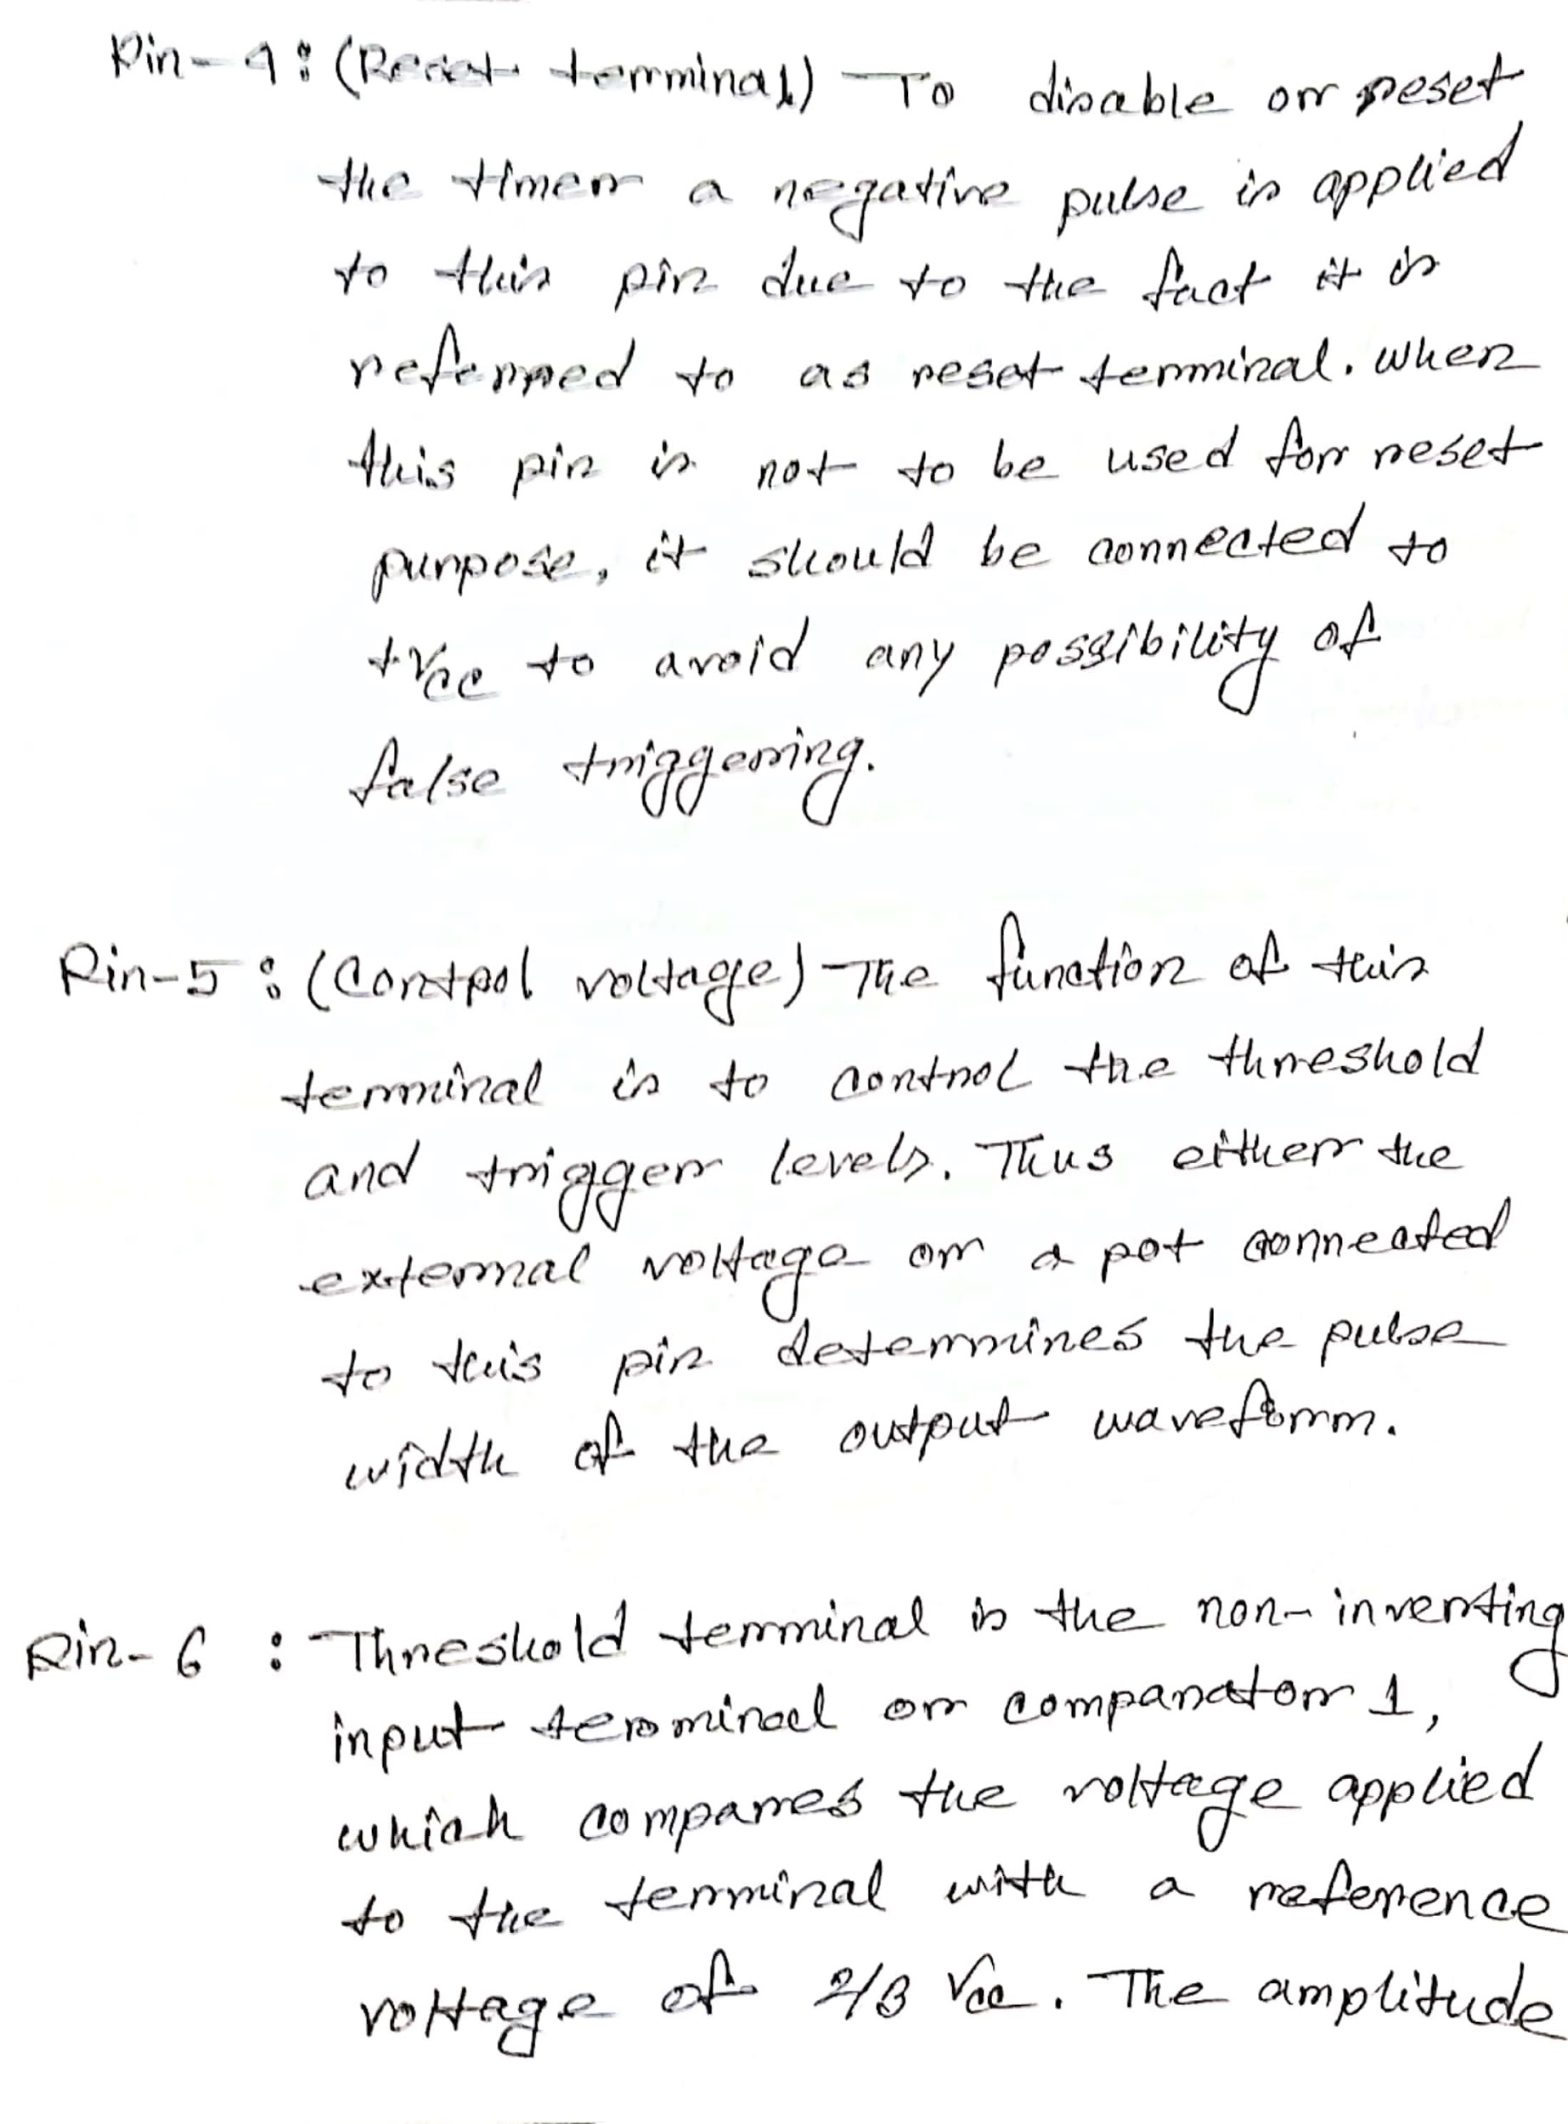

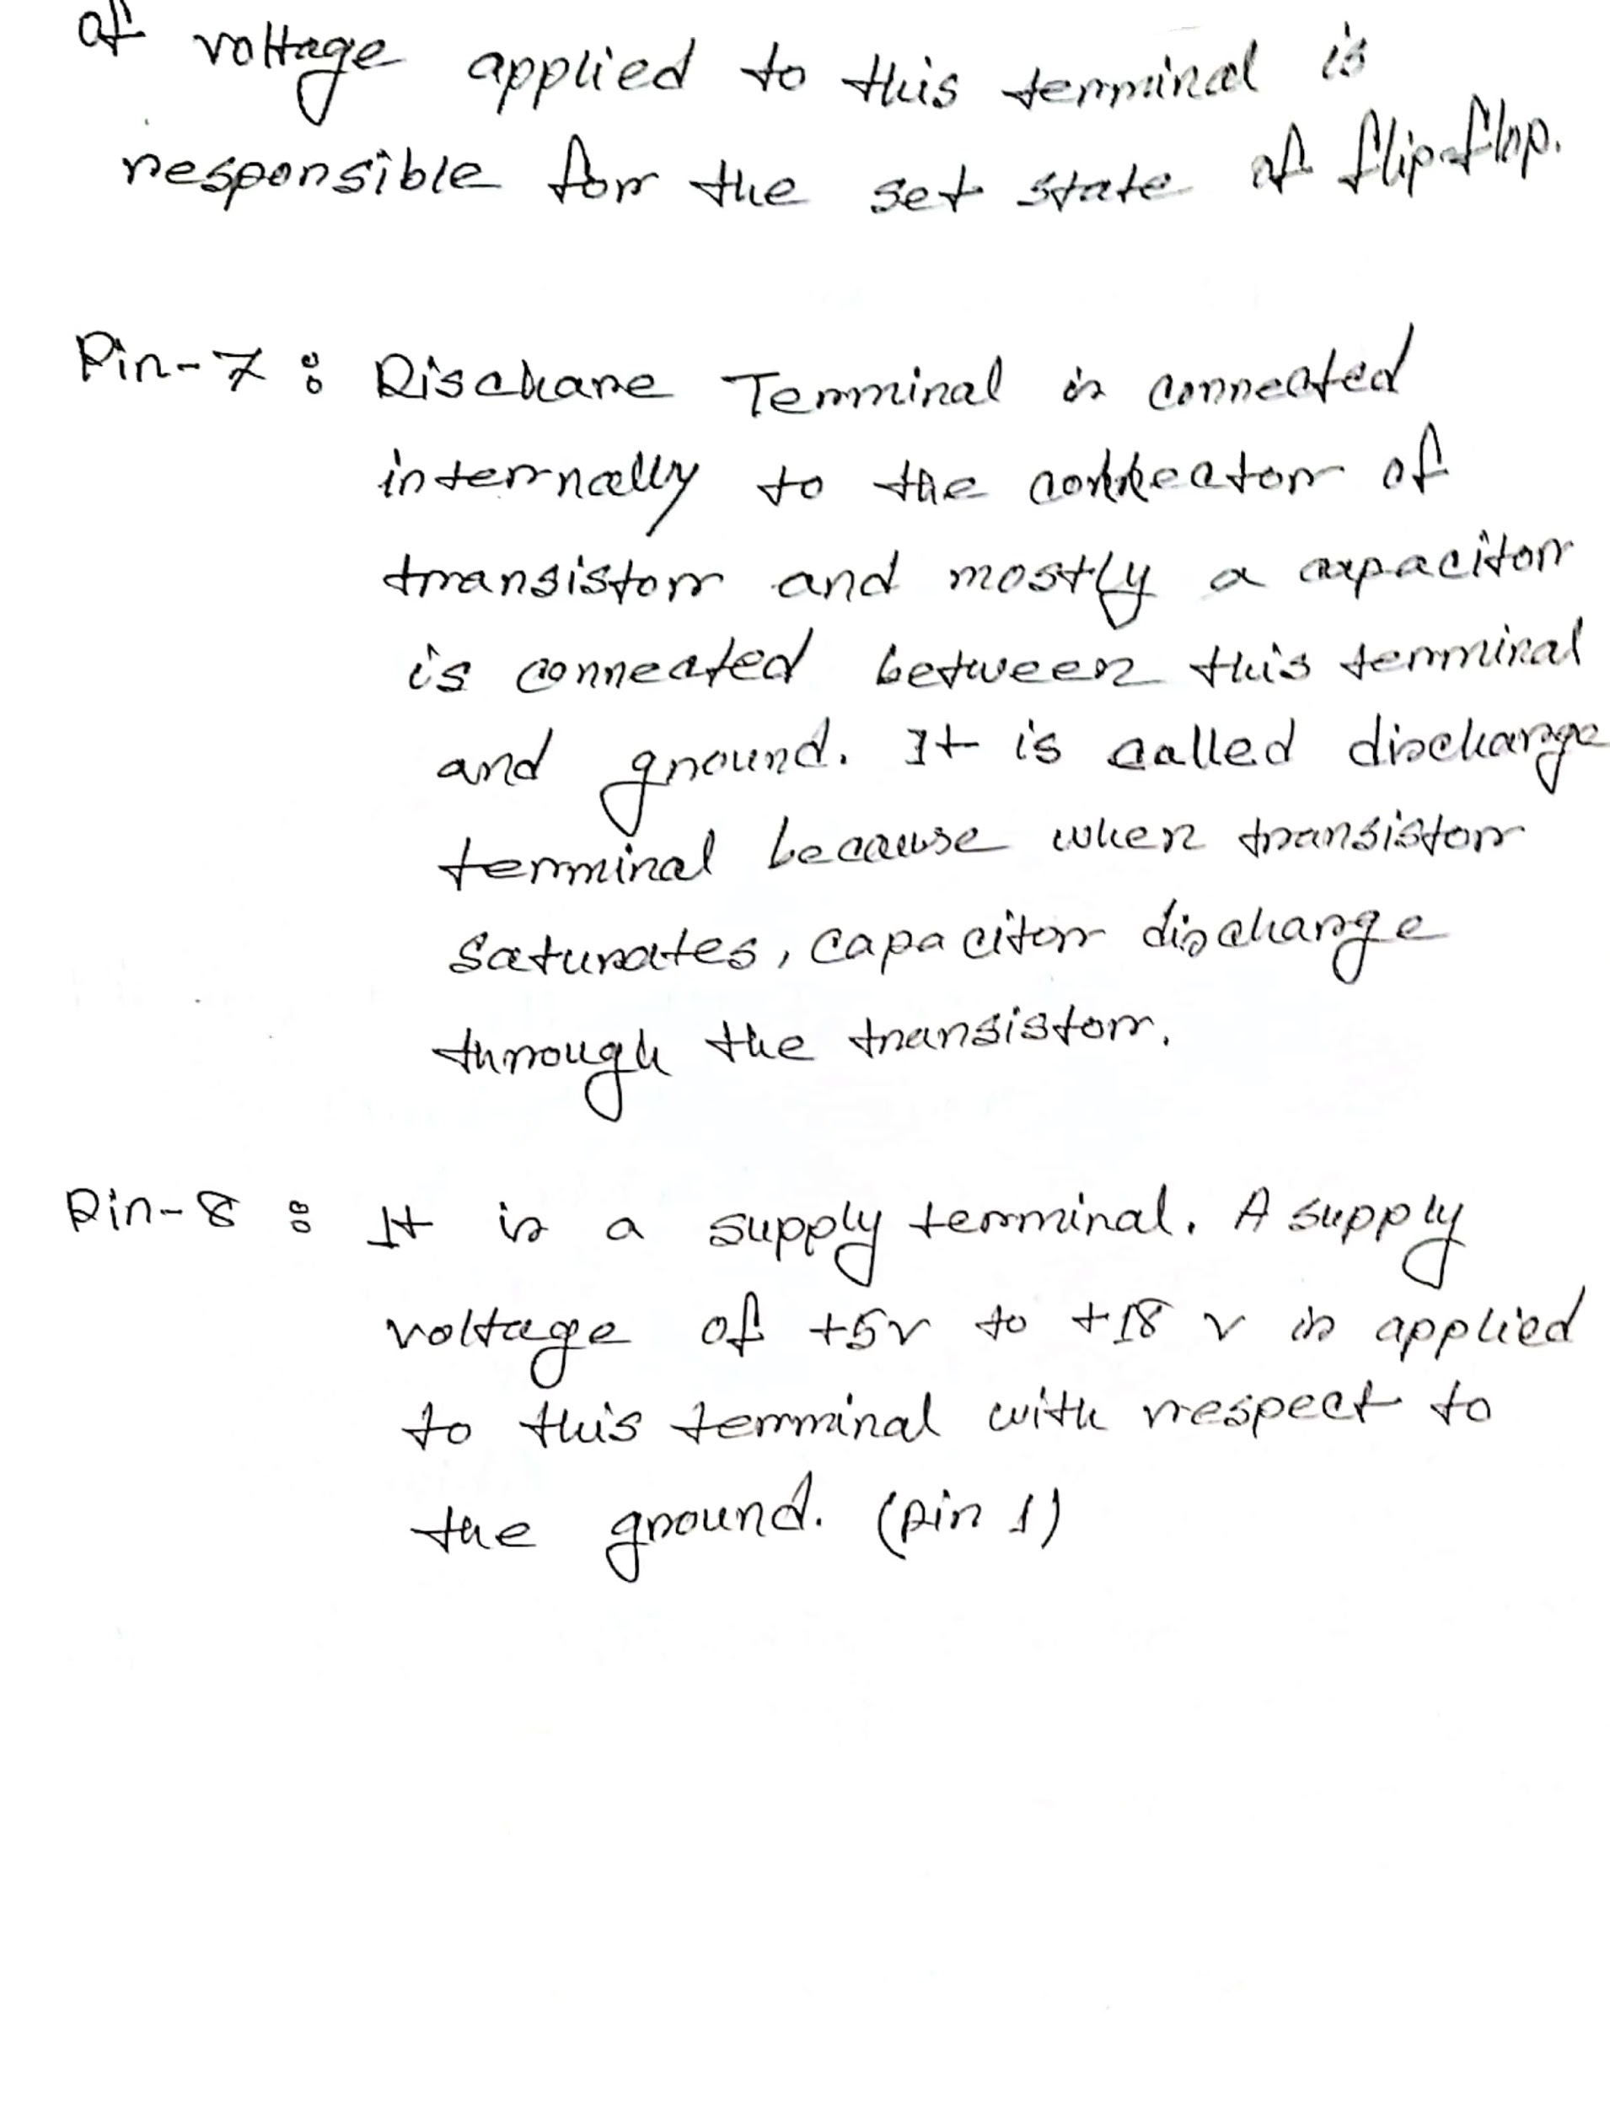

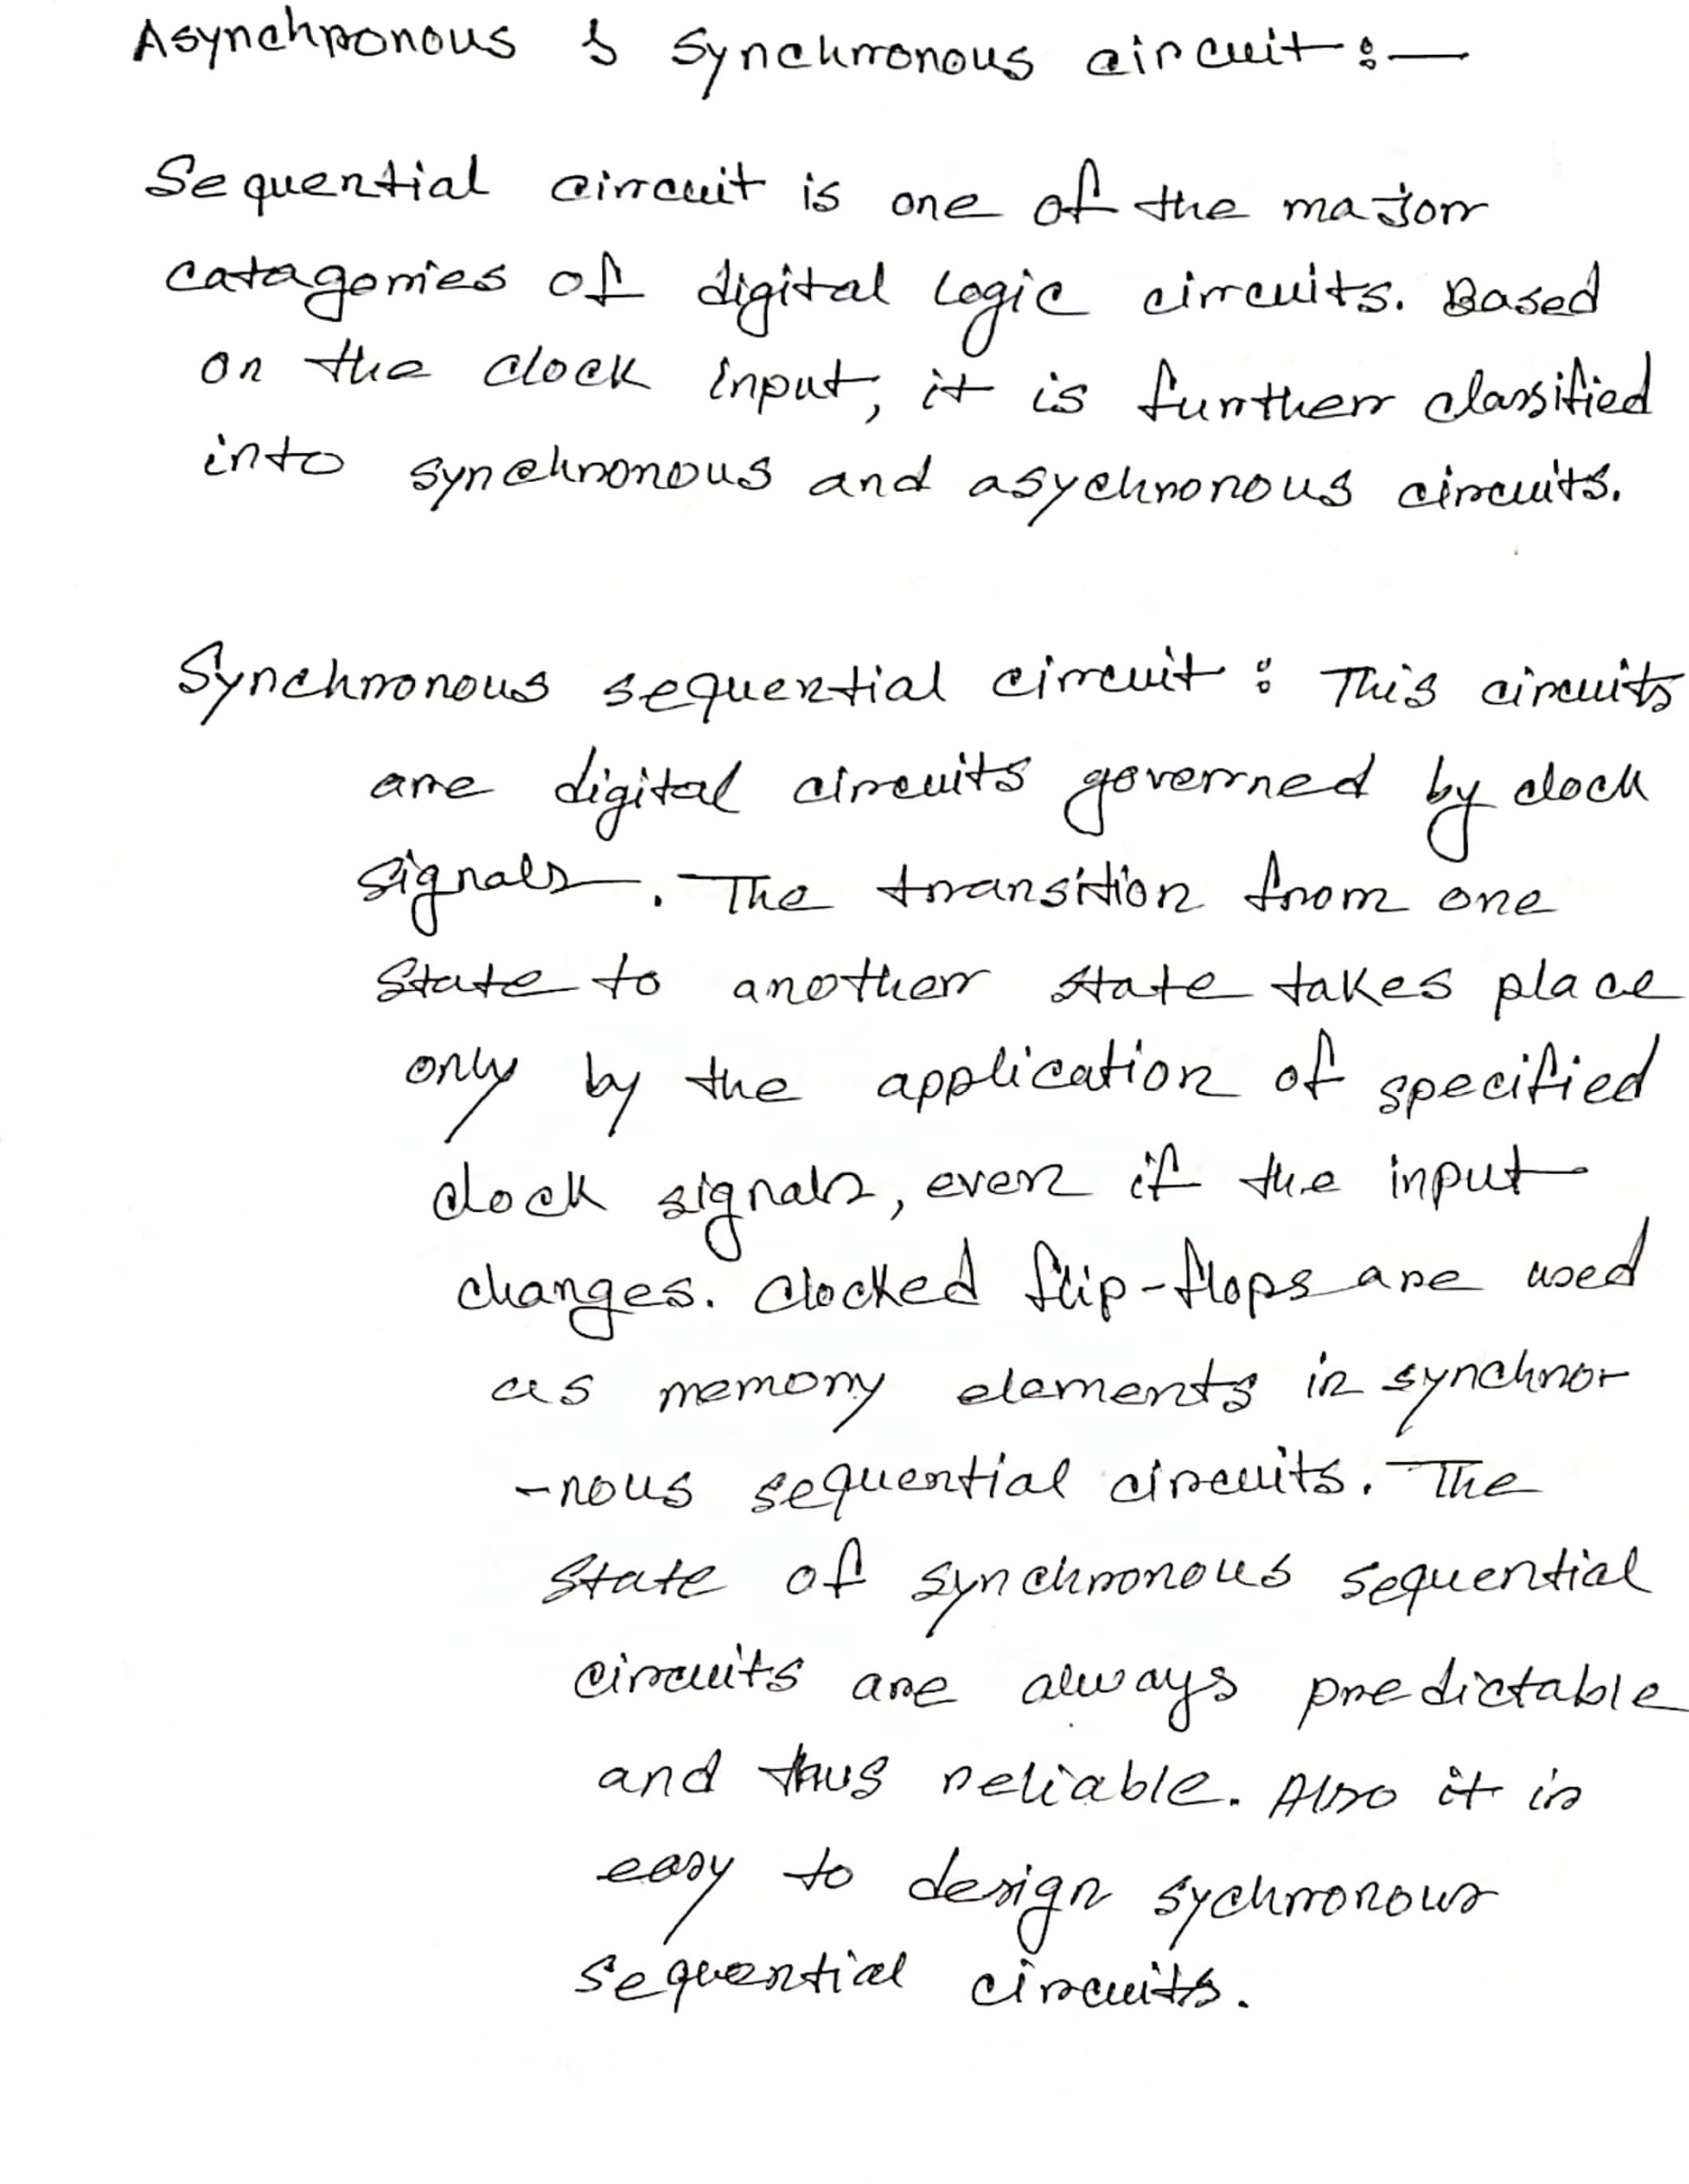

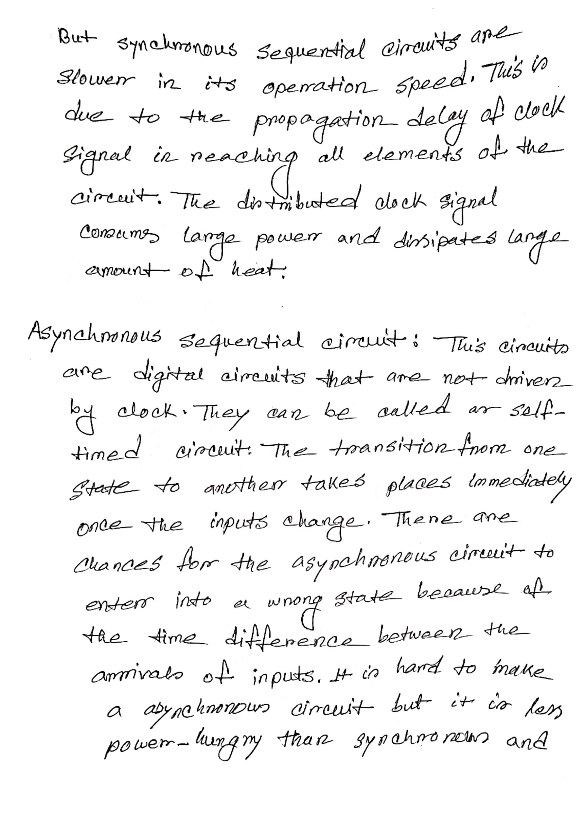

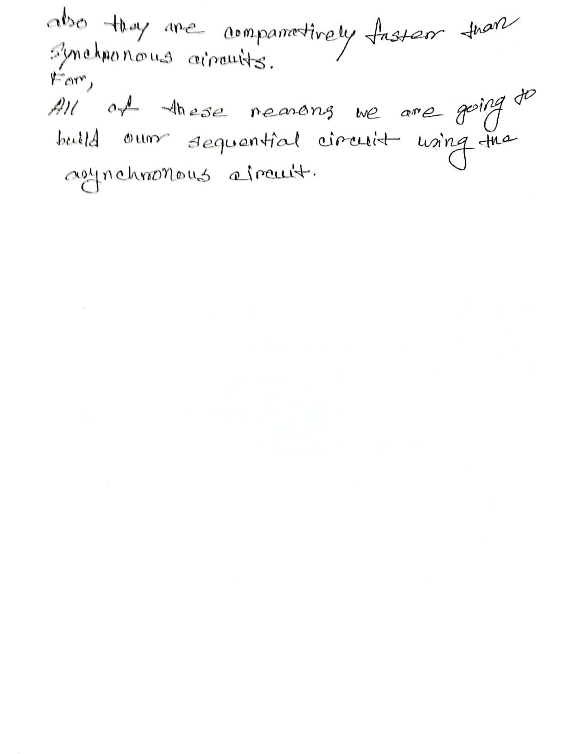

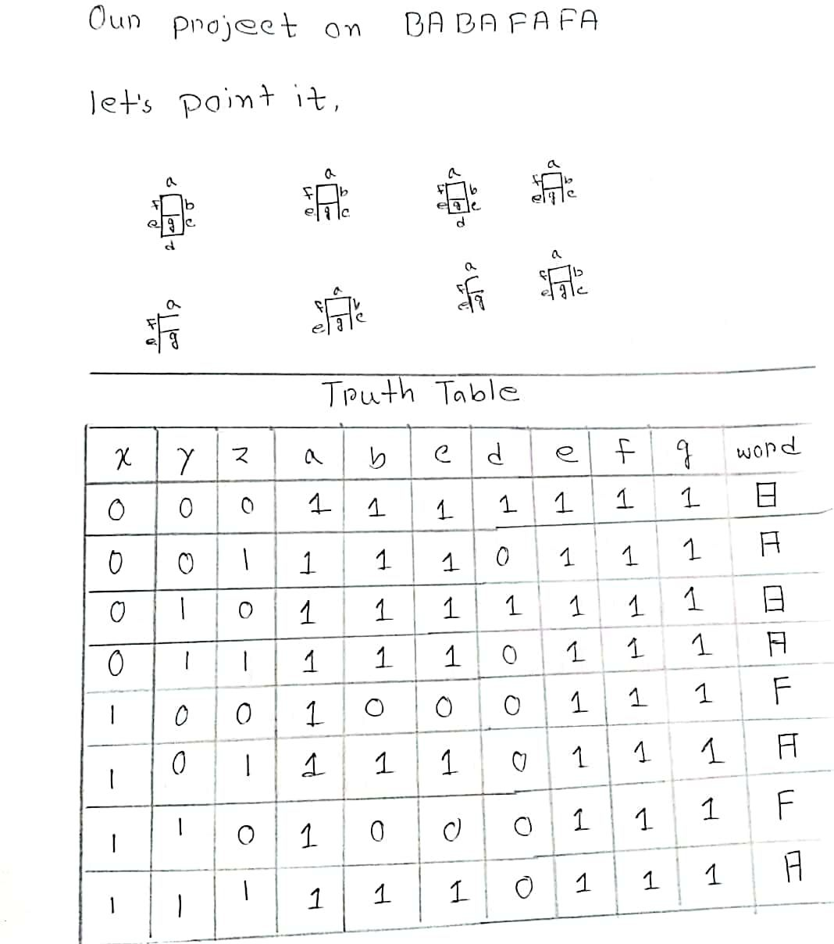  
 **Figure: Table 1**

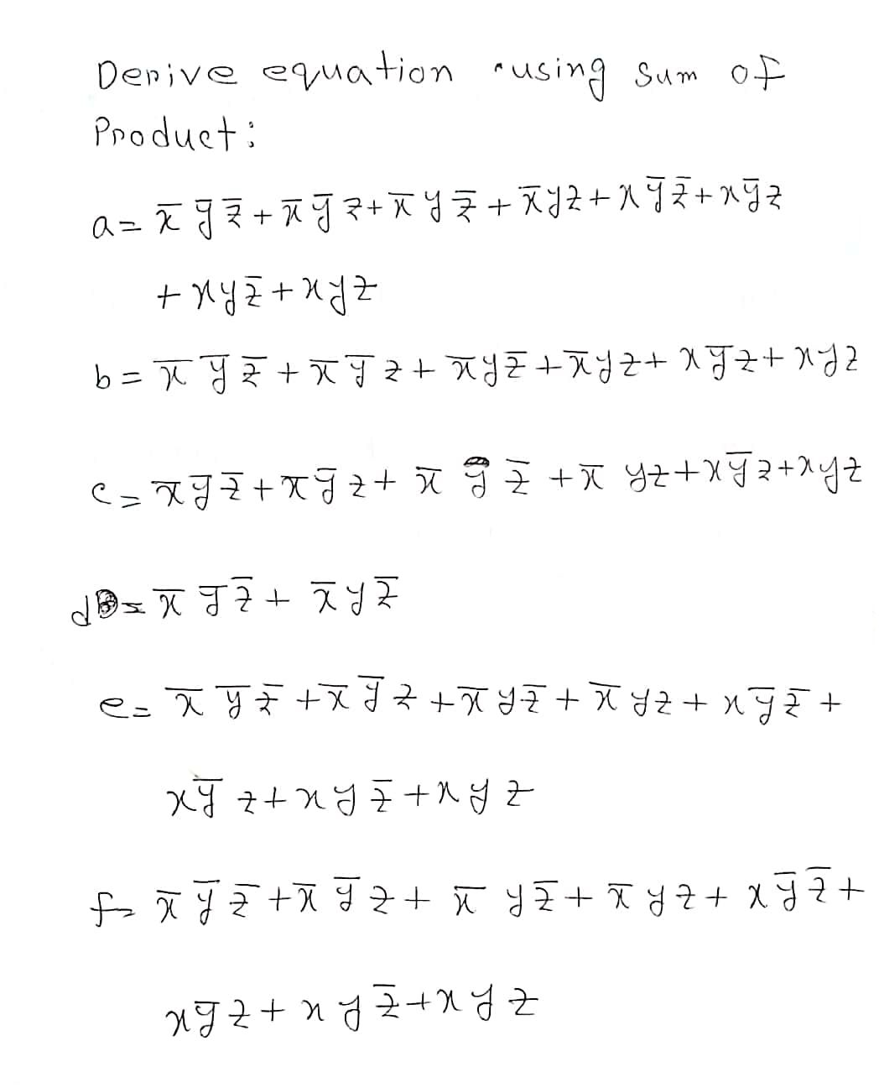  
  
  
  
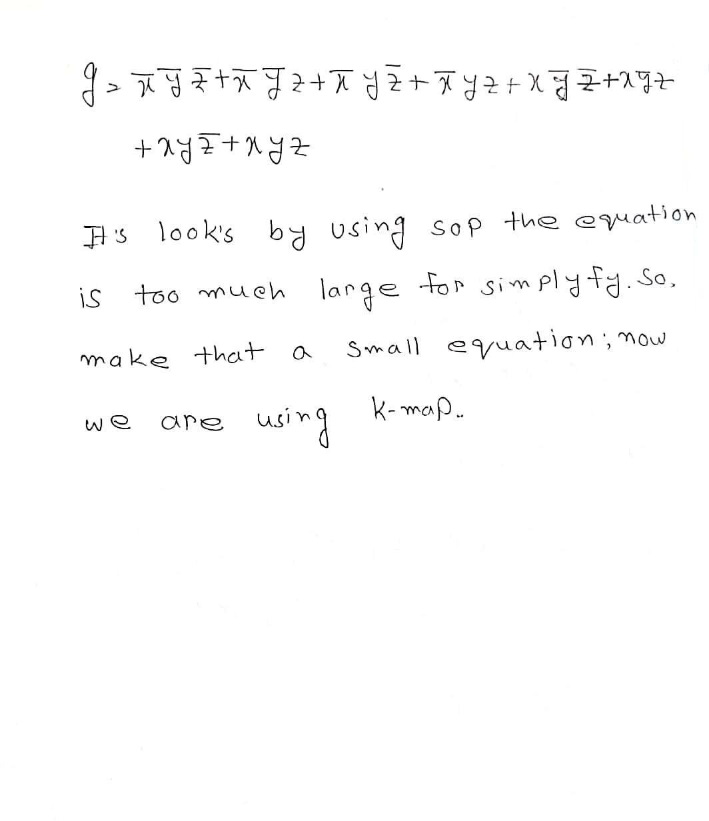  
  
  
  
  
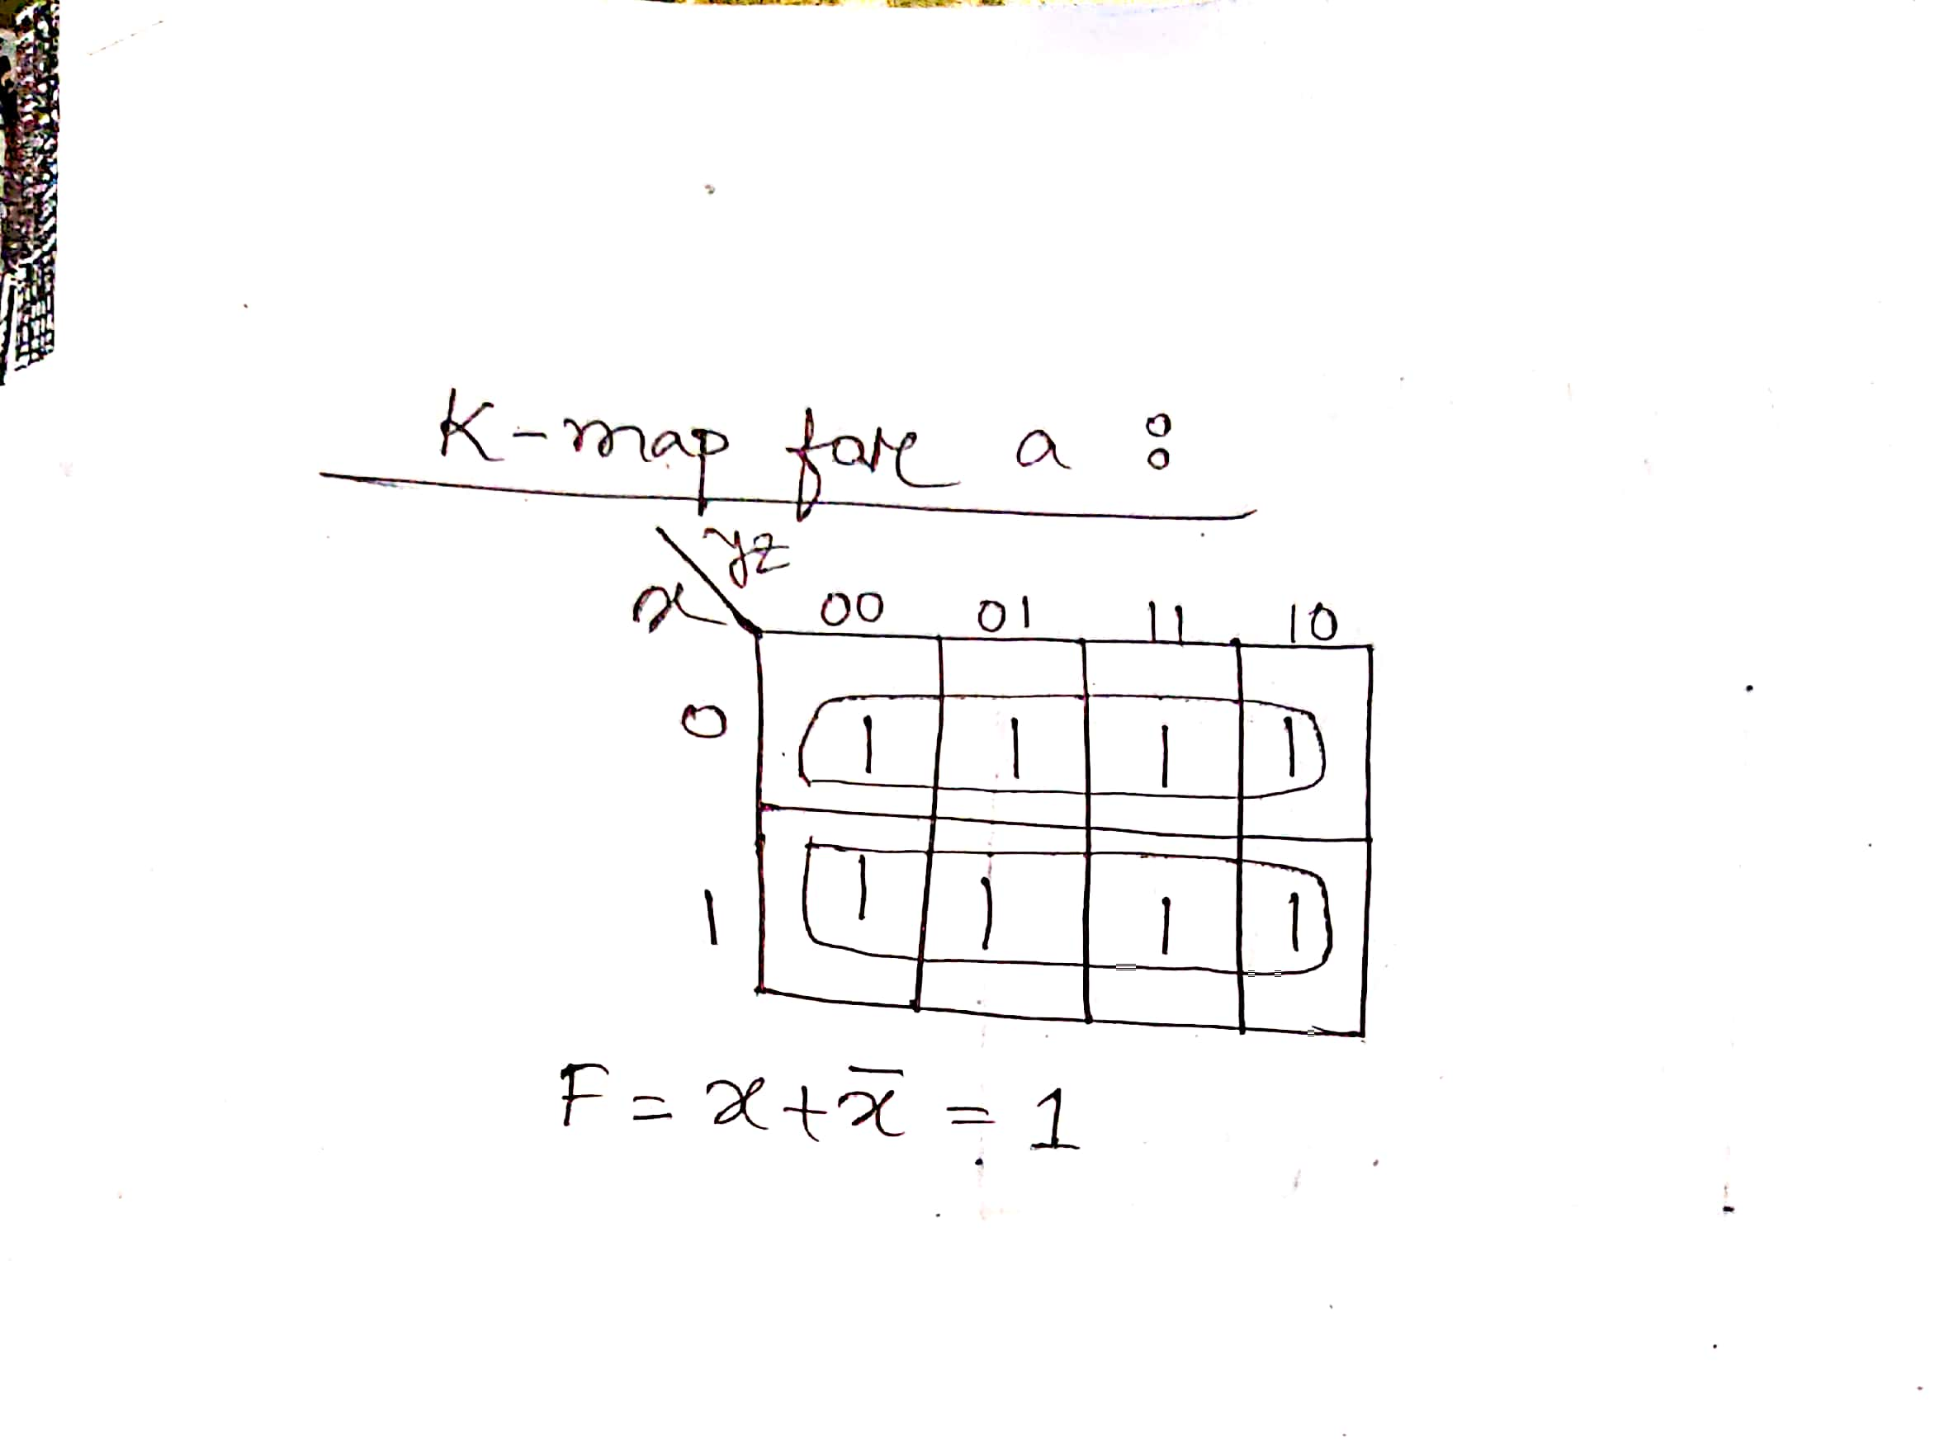  
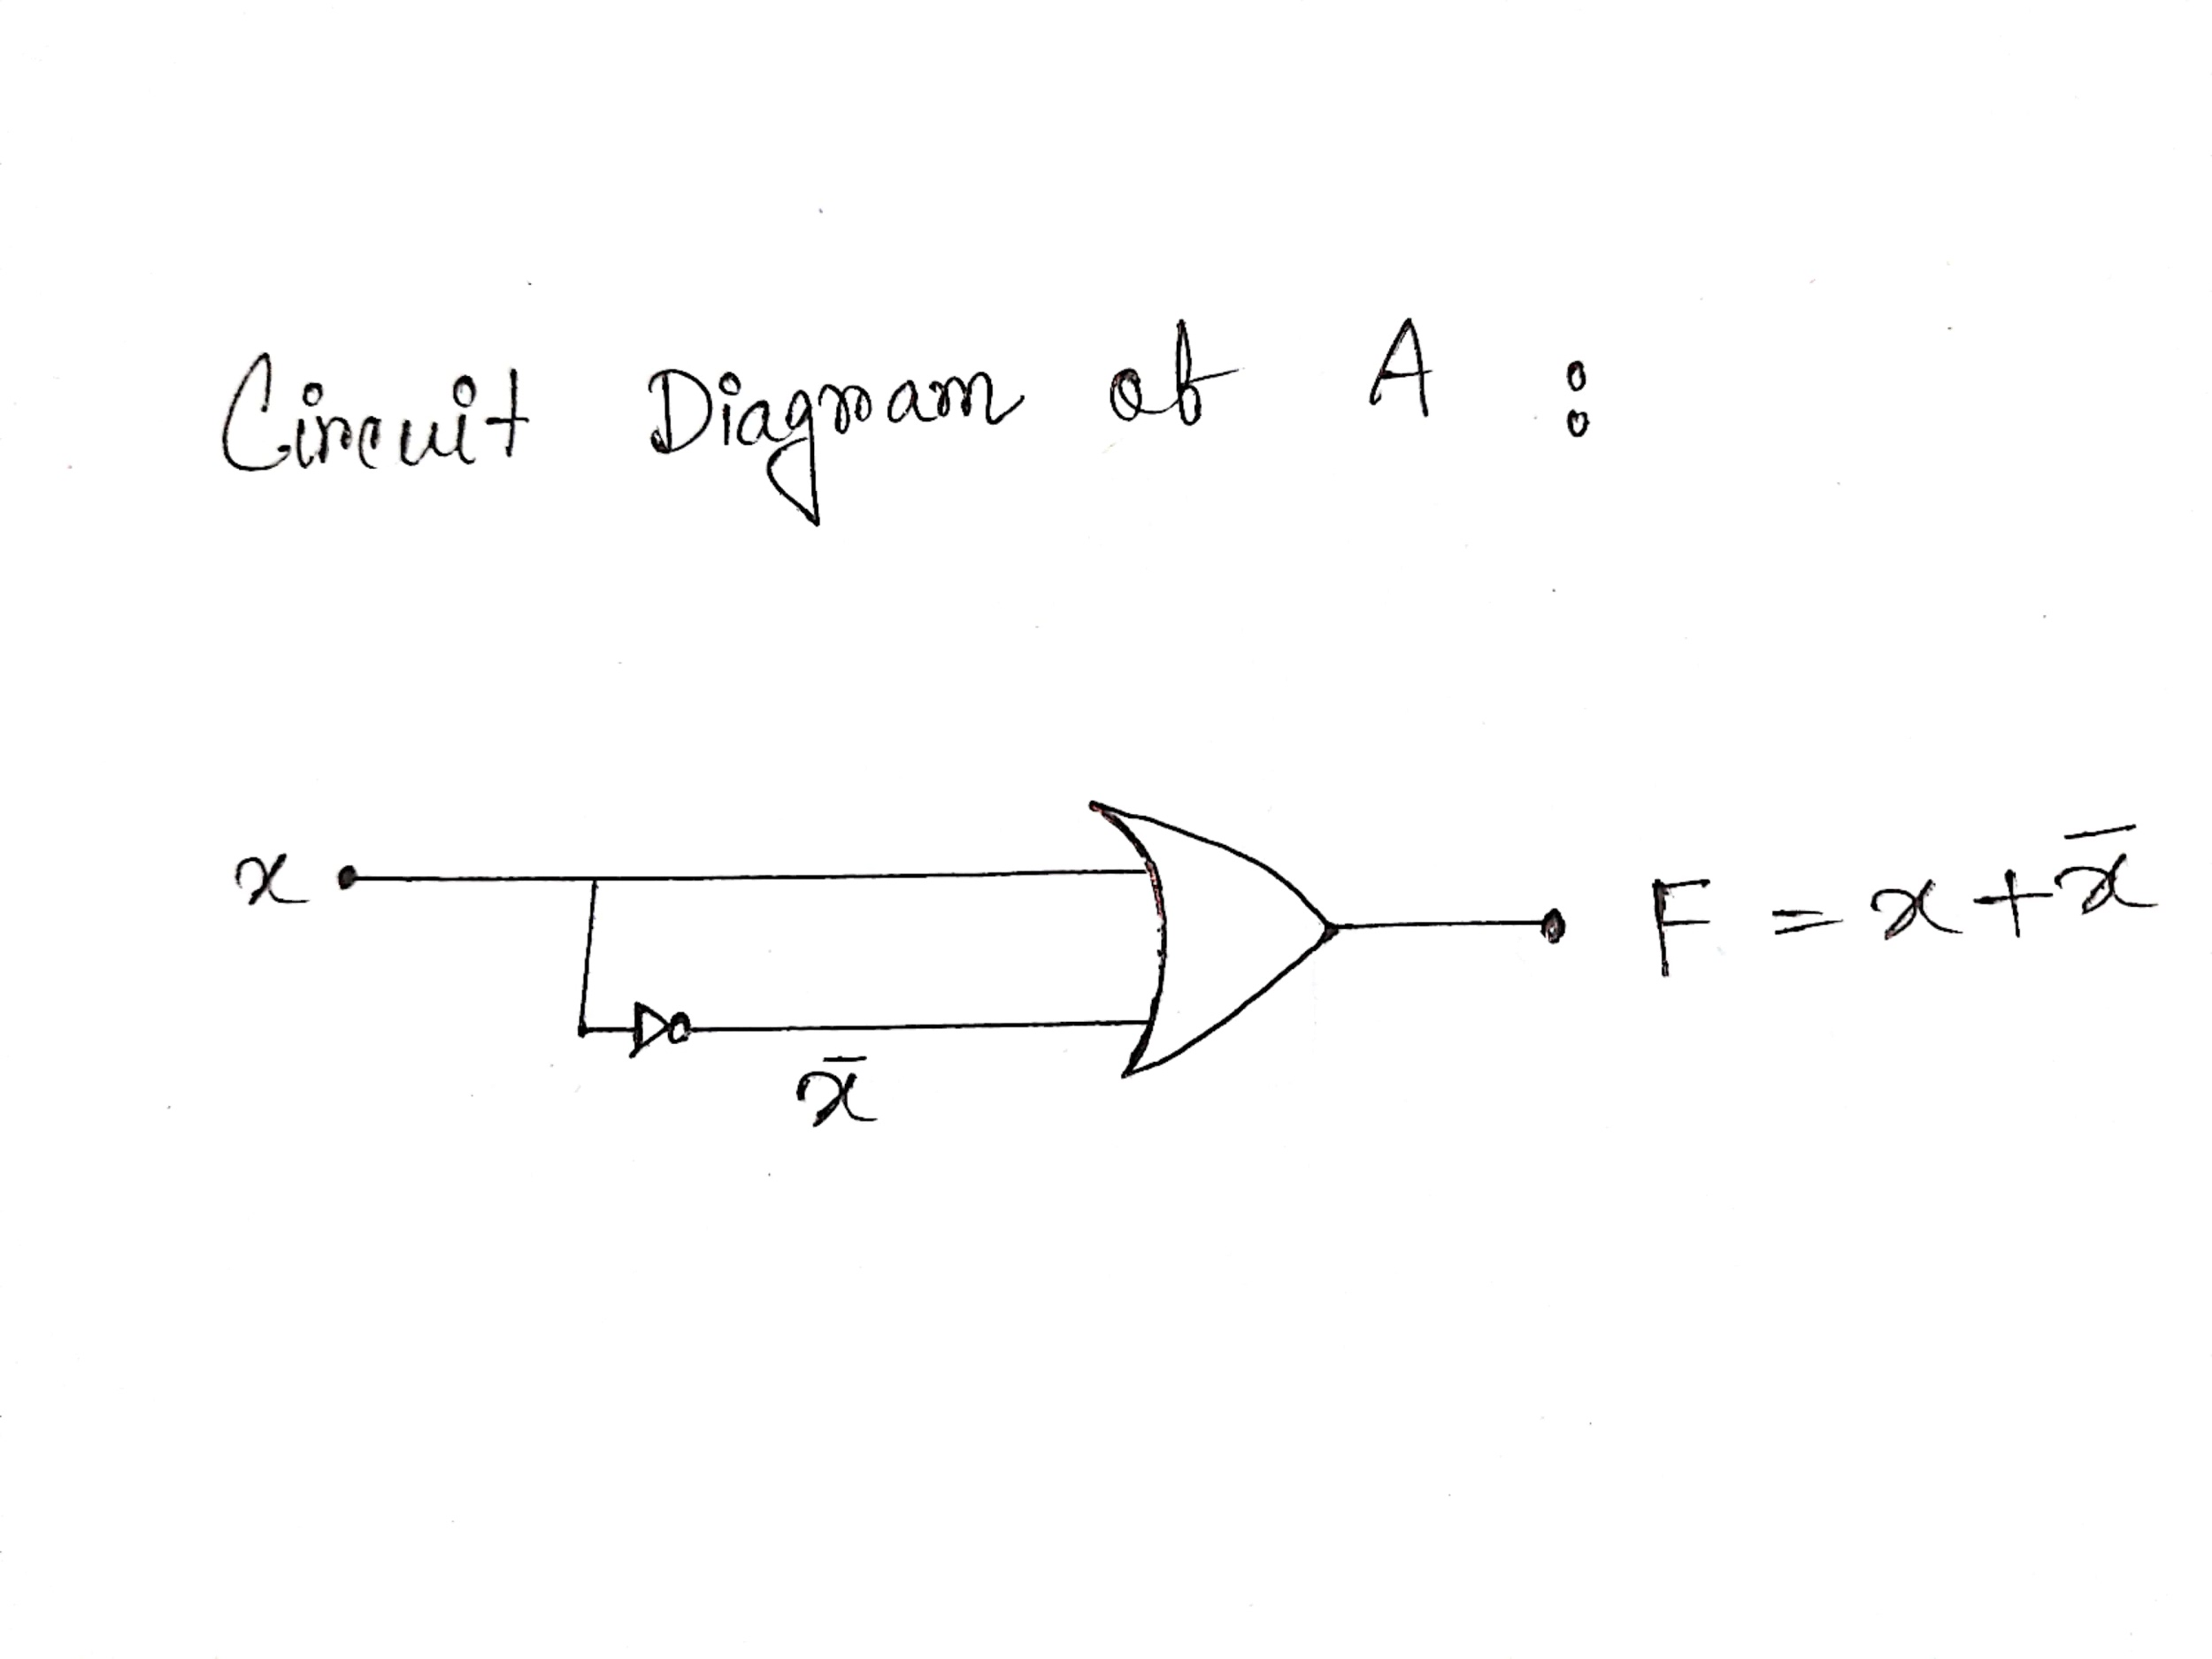  
  
  
  
  
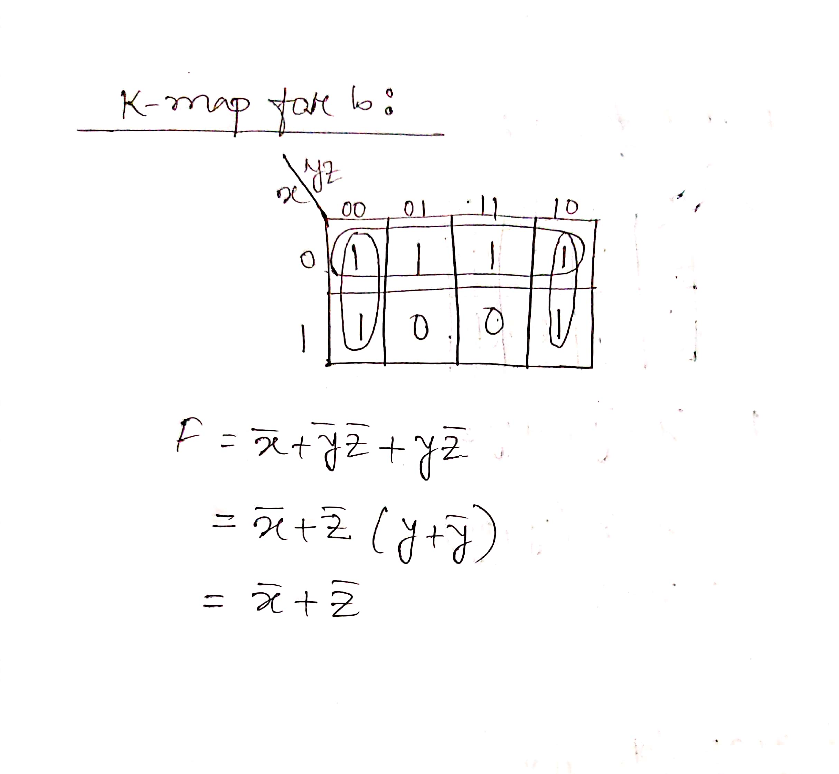  
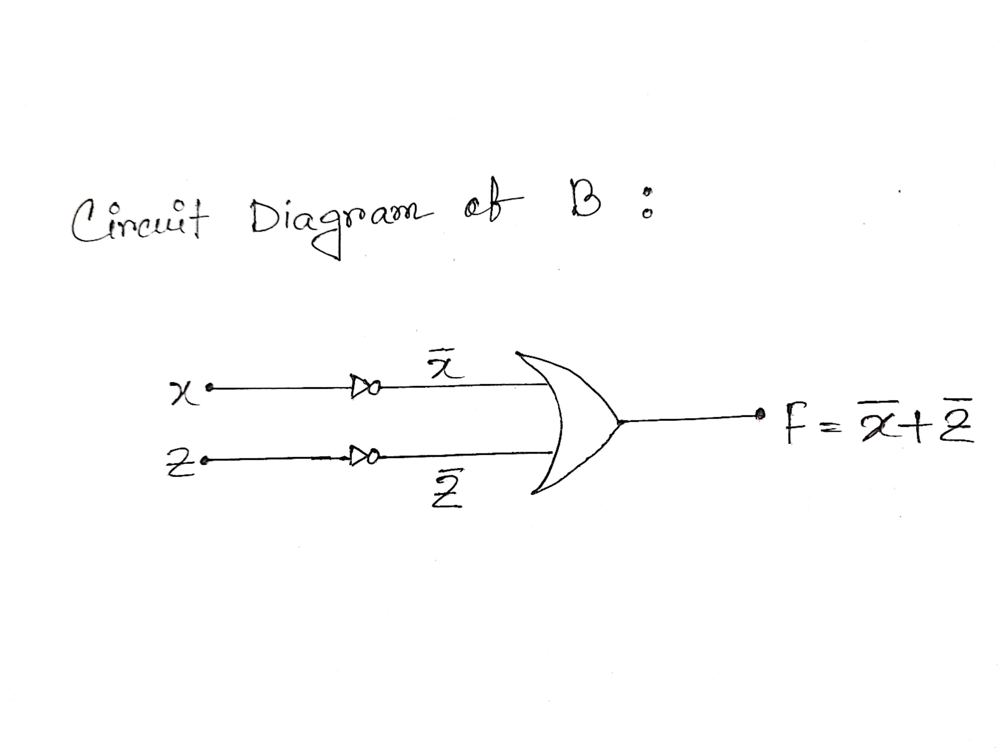  
  
  
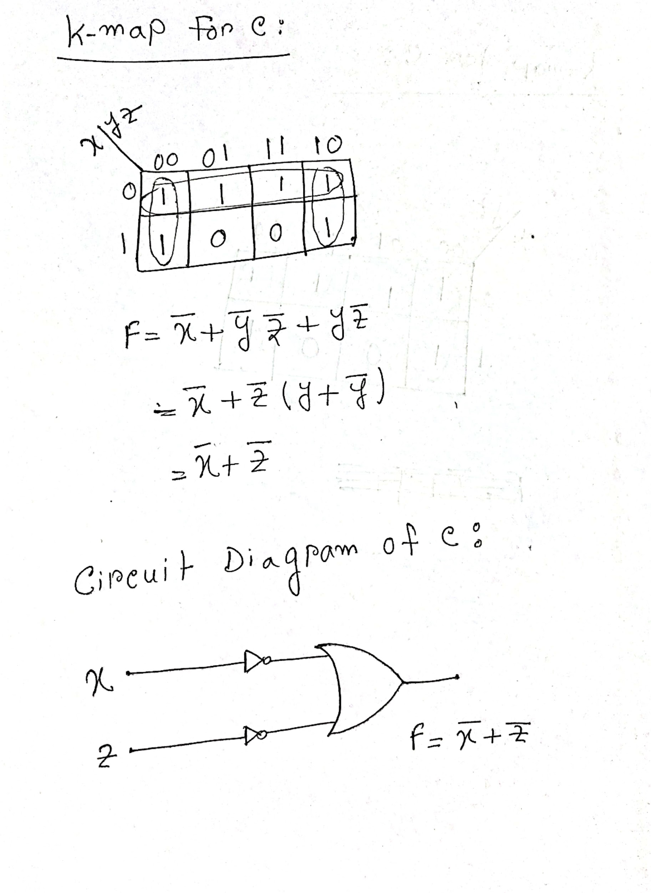

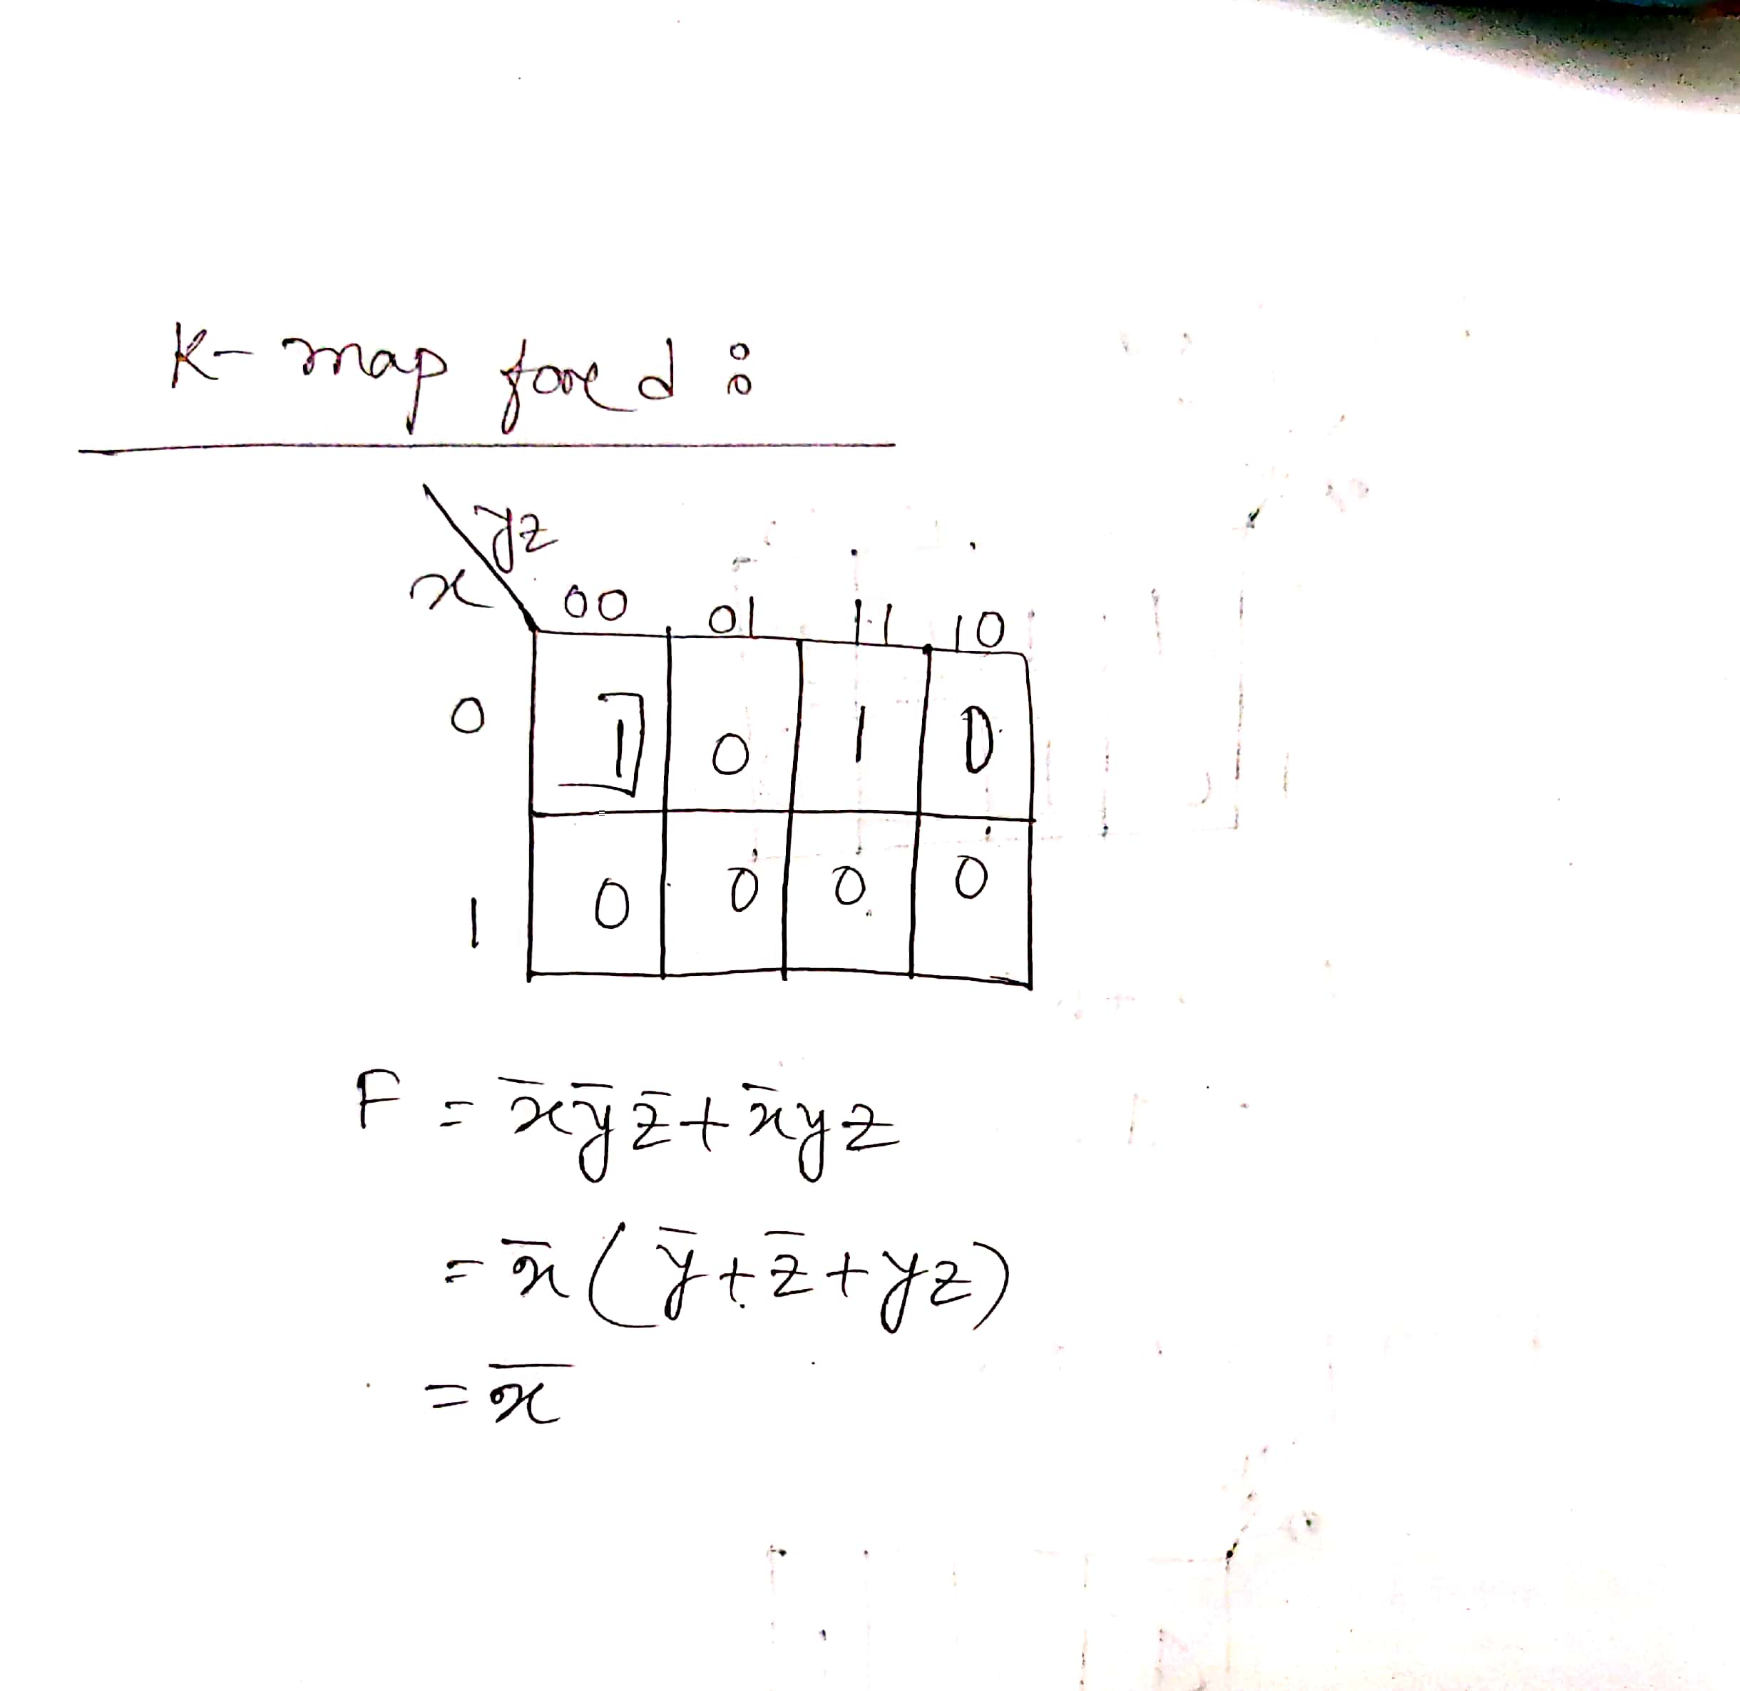  
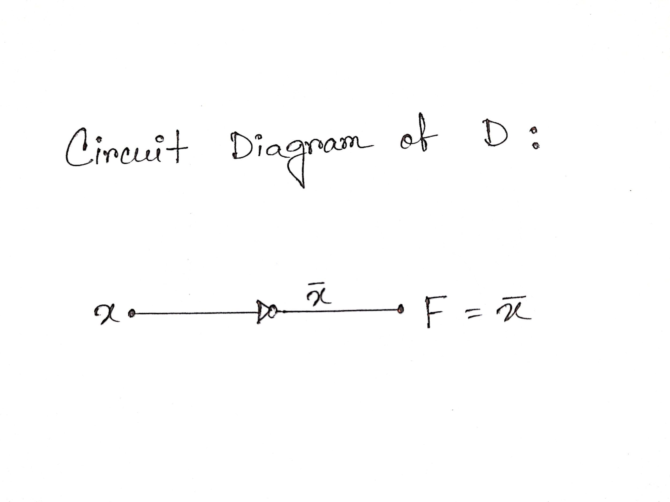  
  
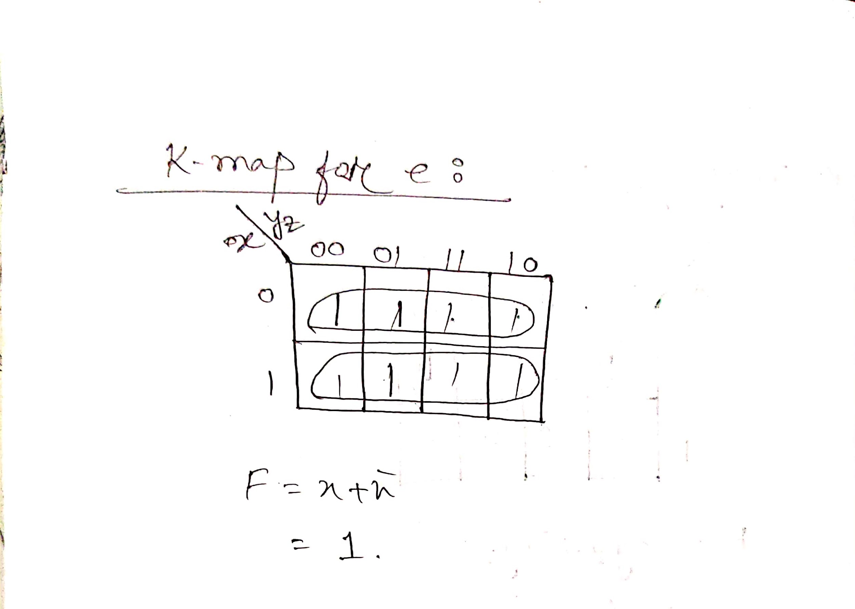  
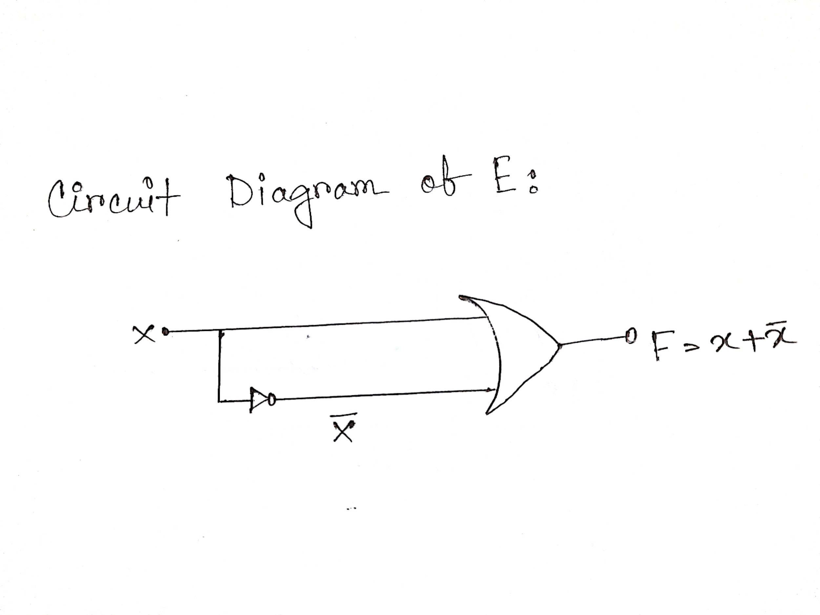  
  
  
  
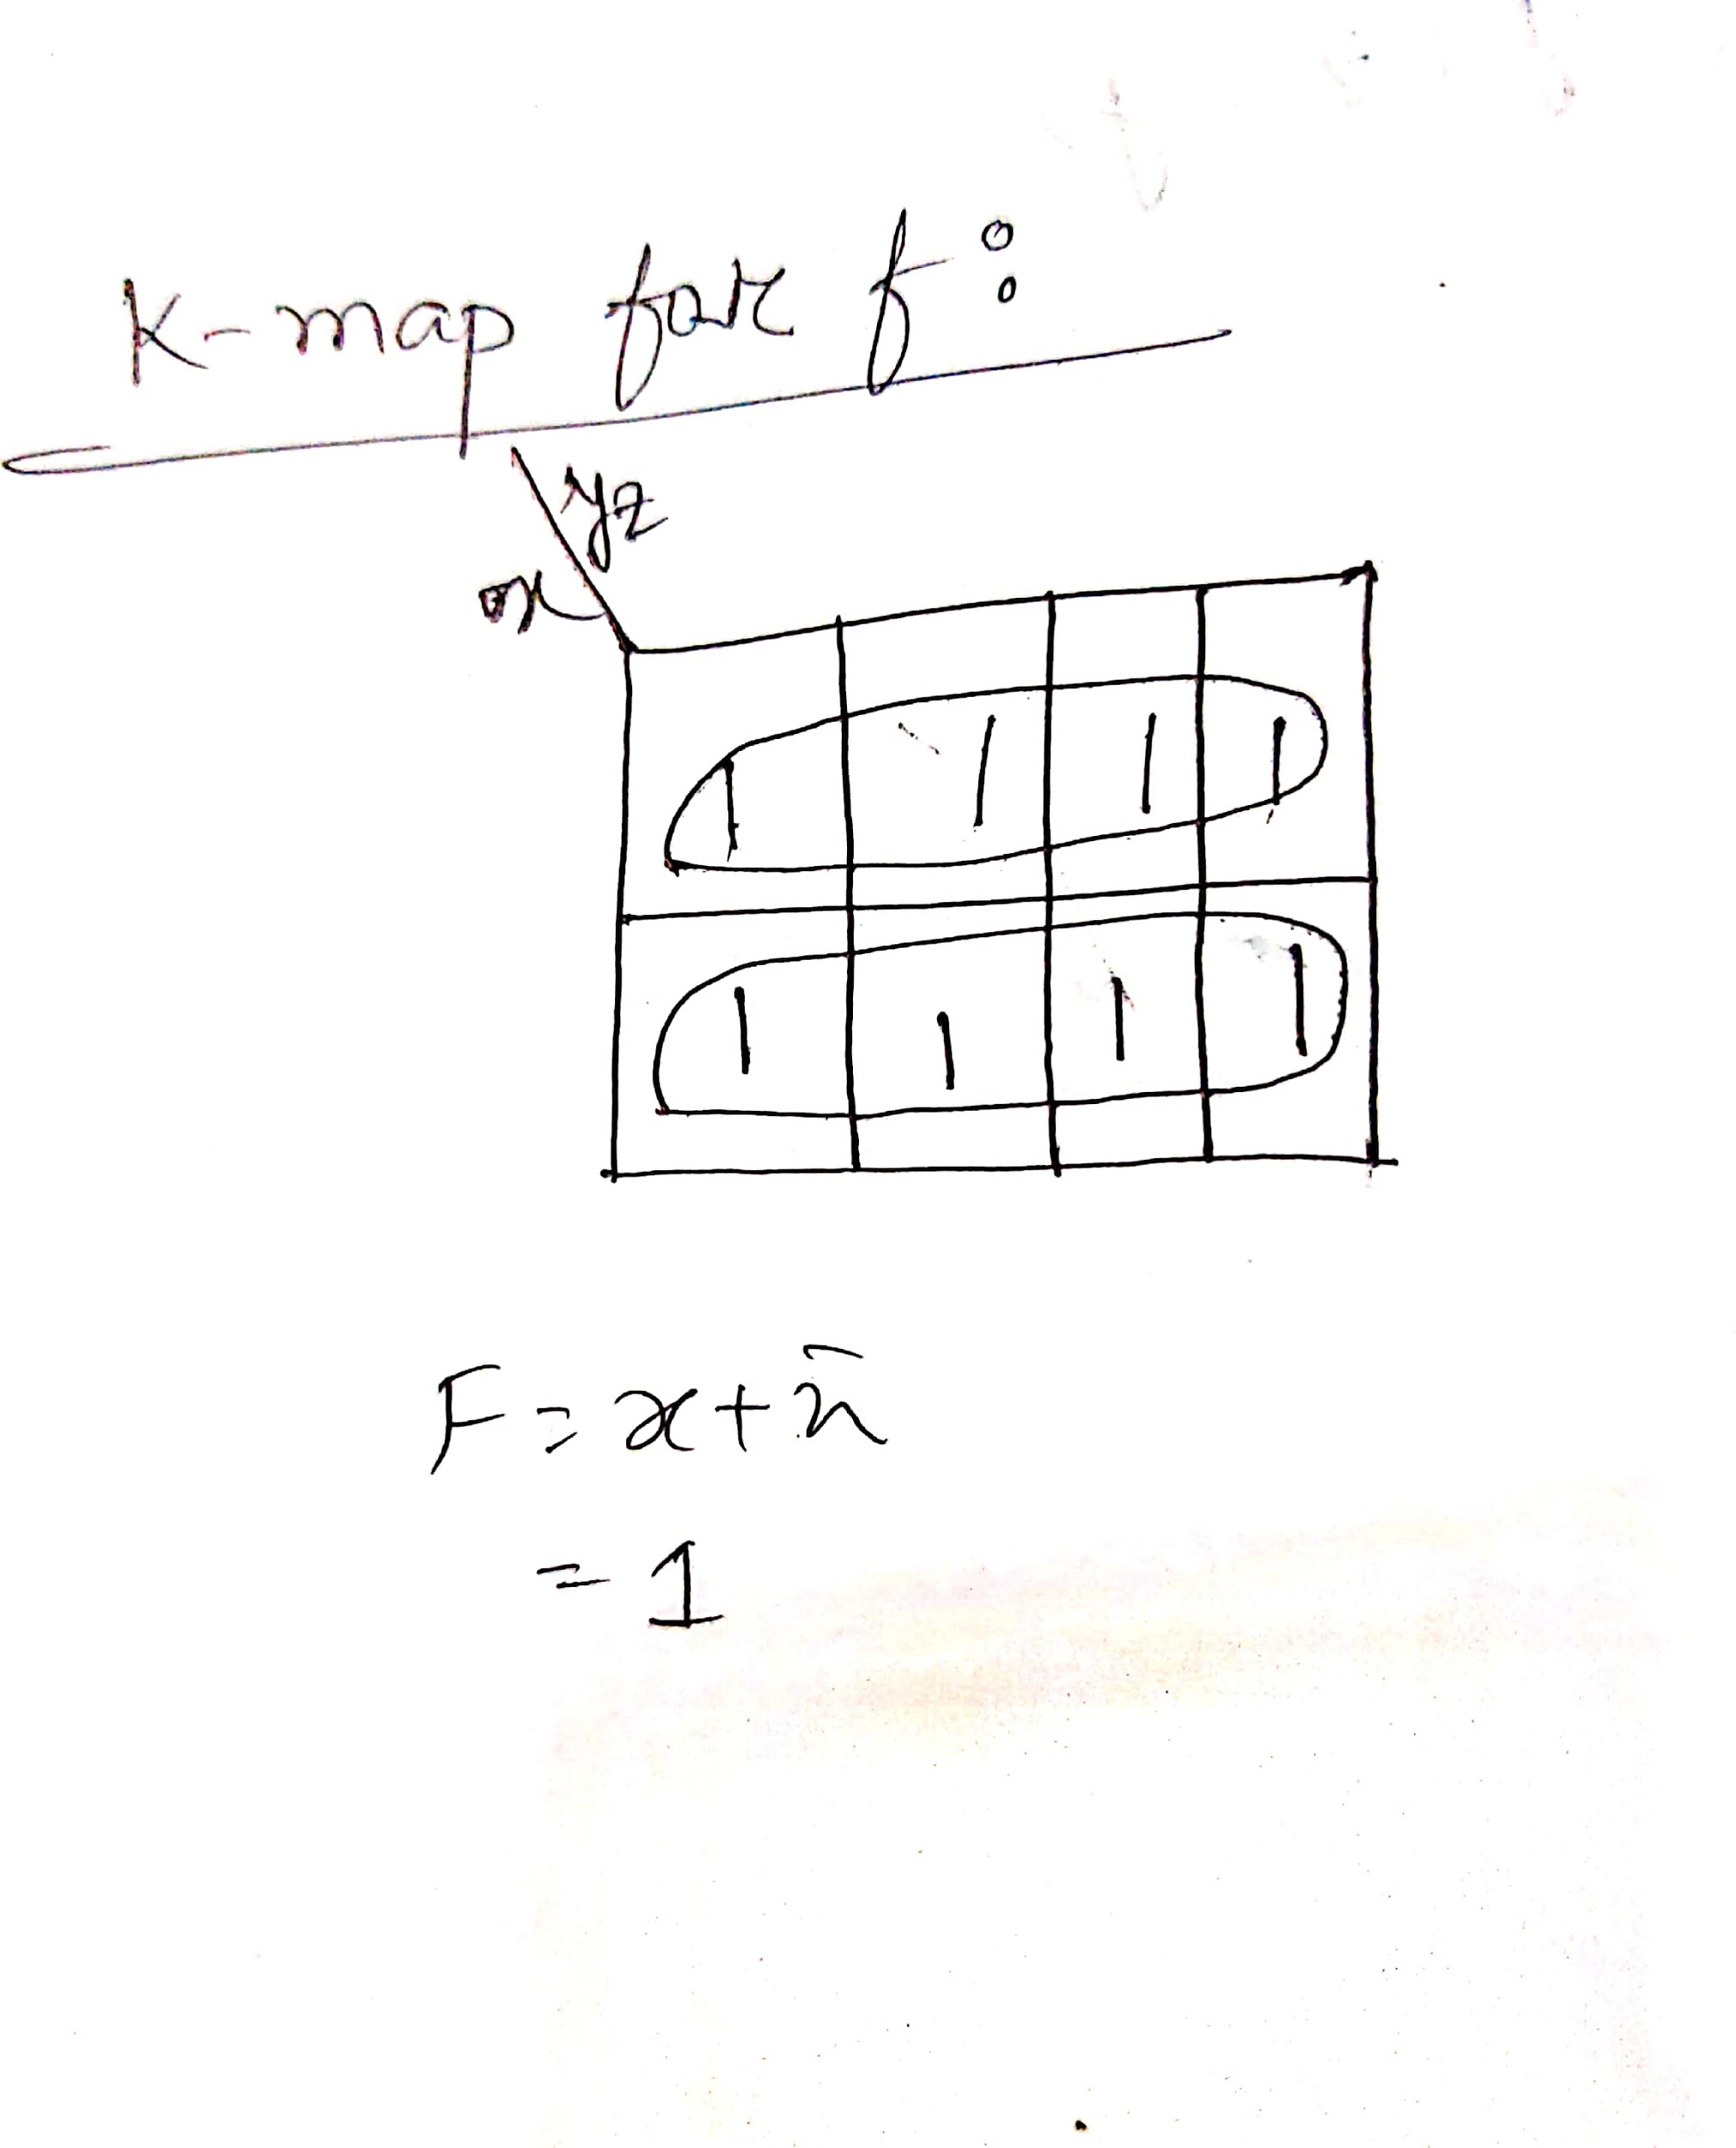  
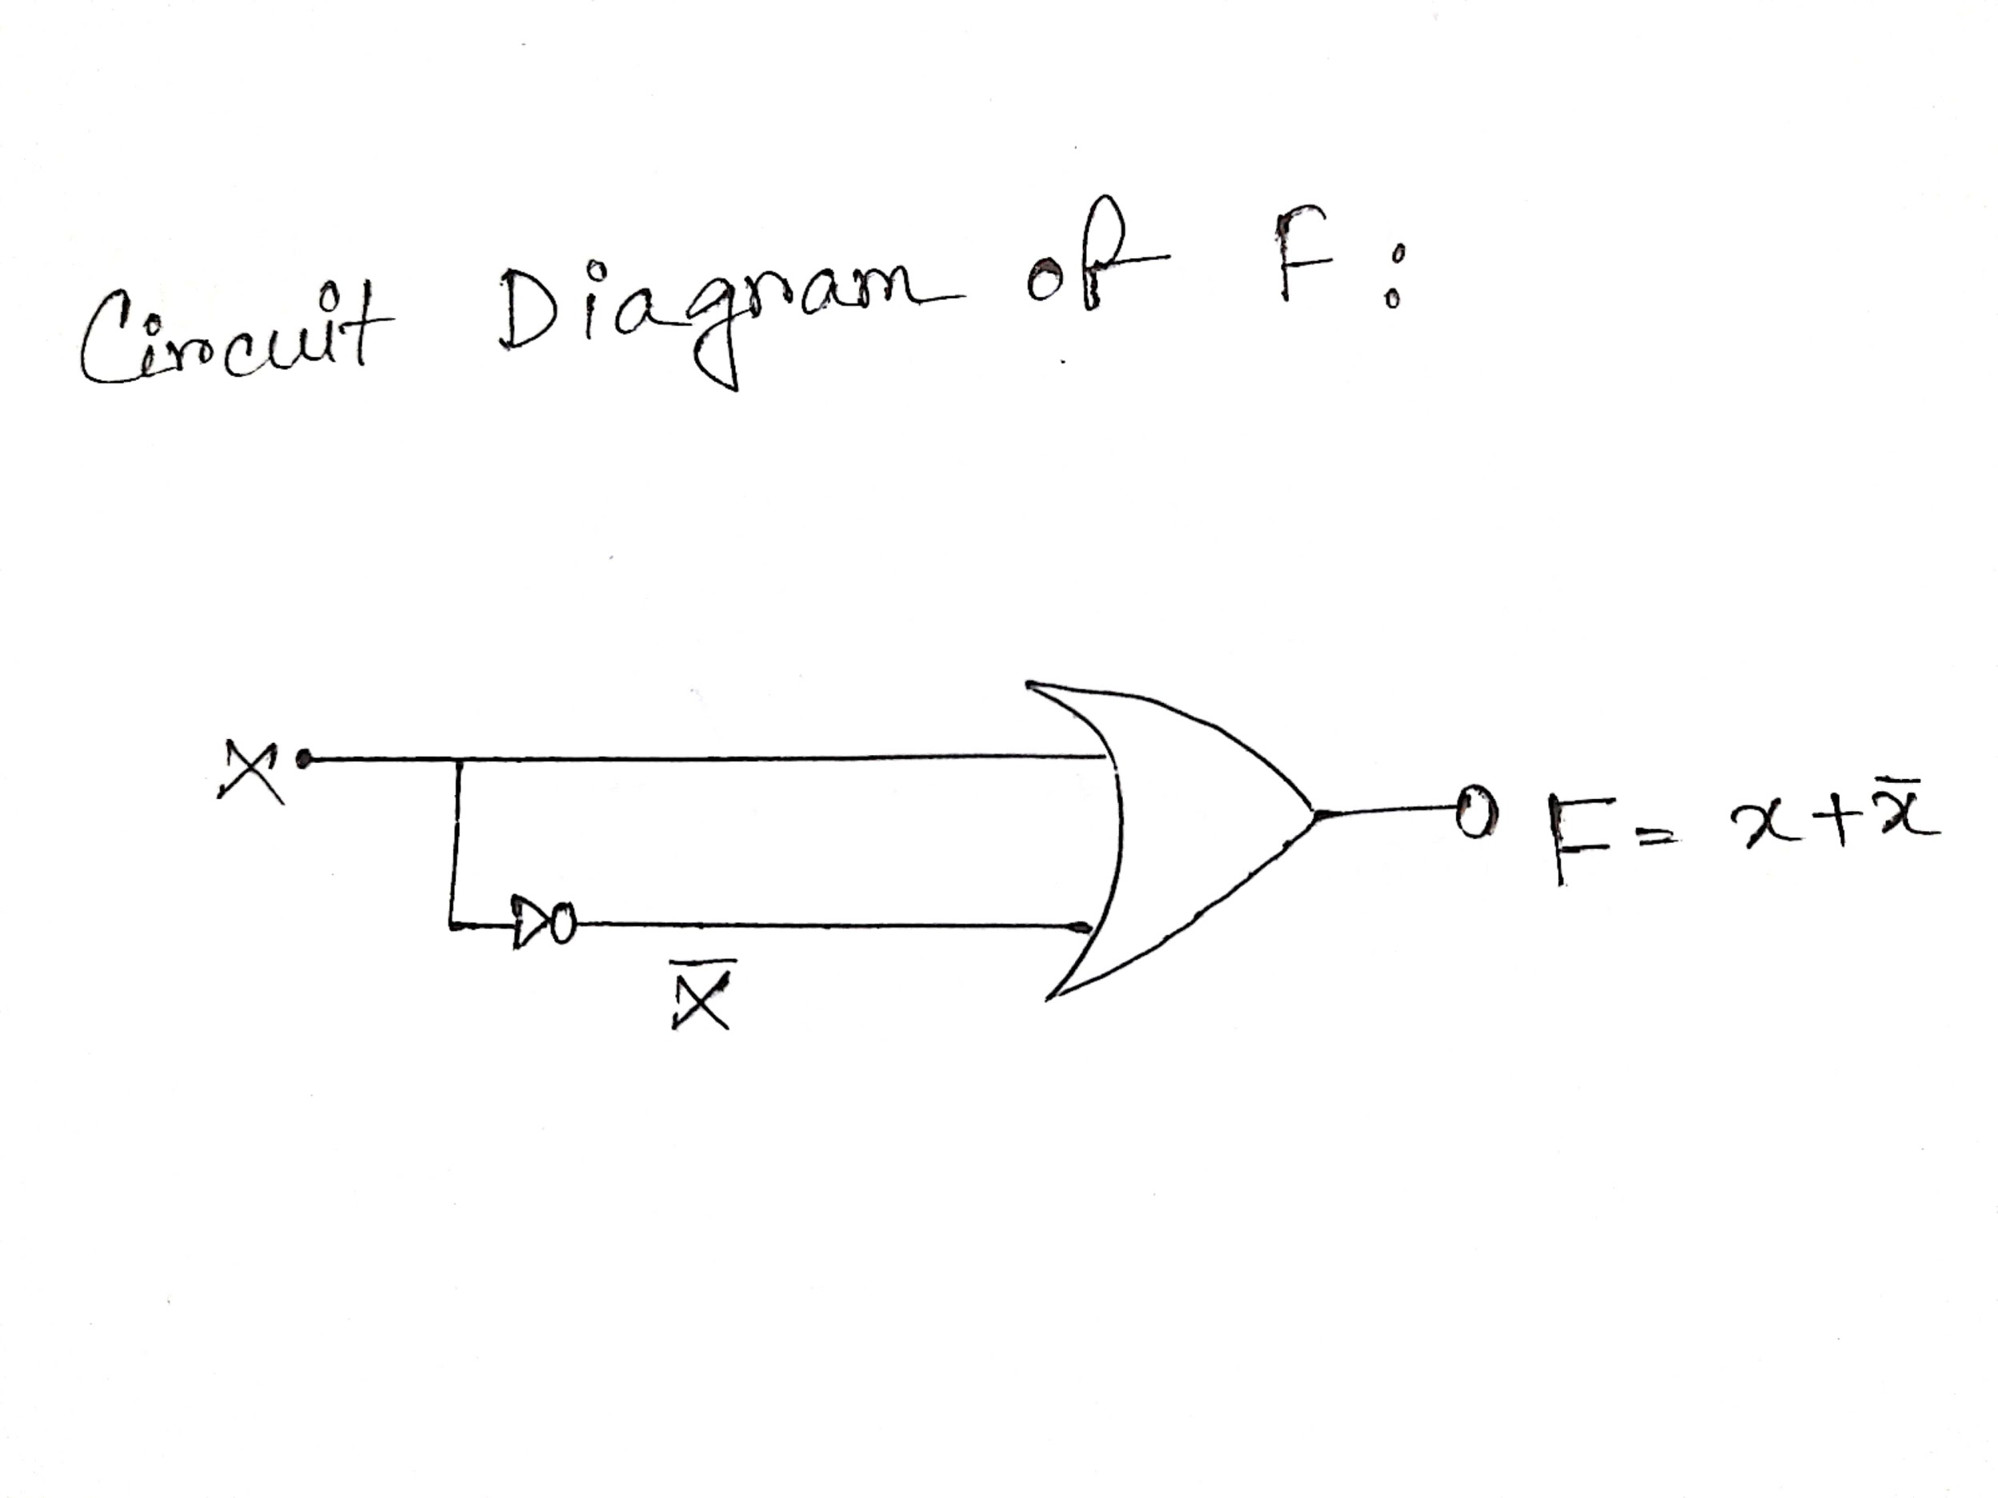  
  
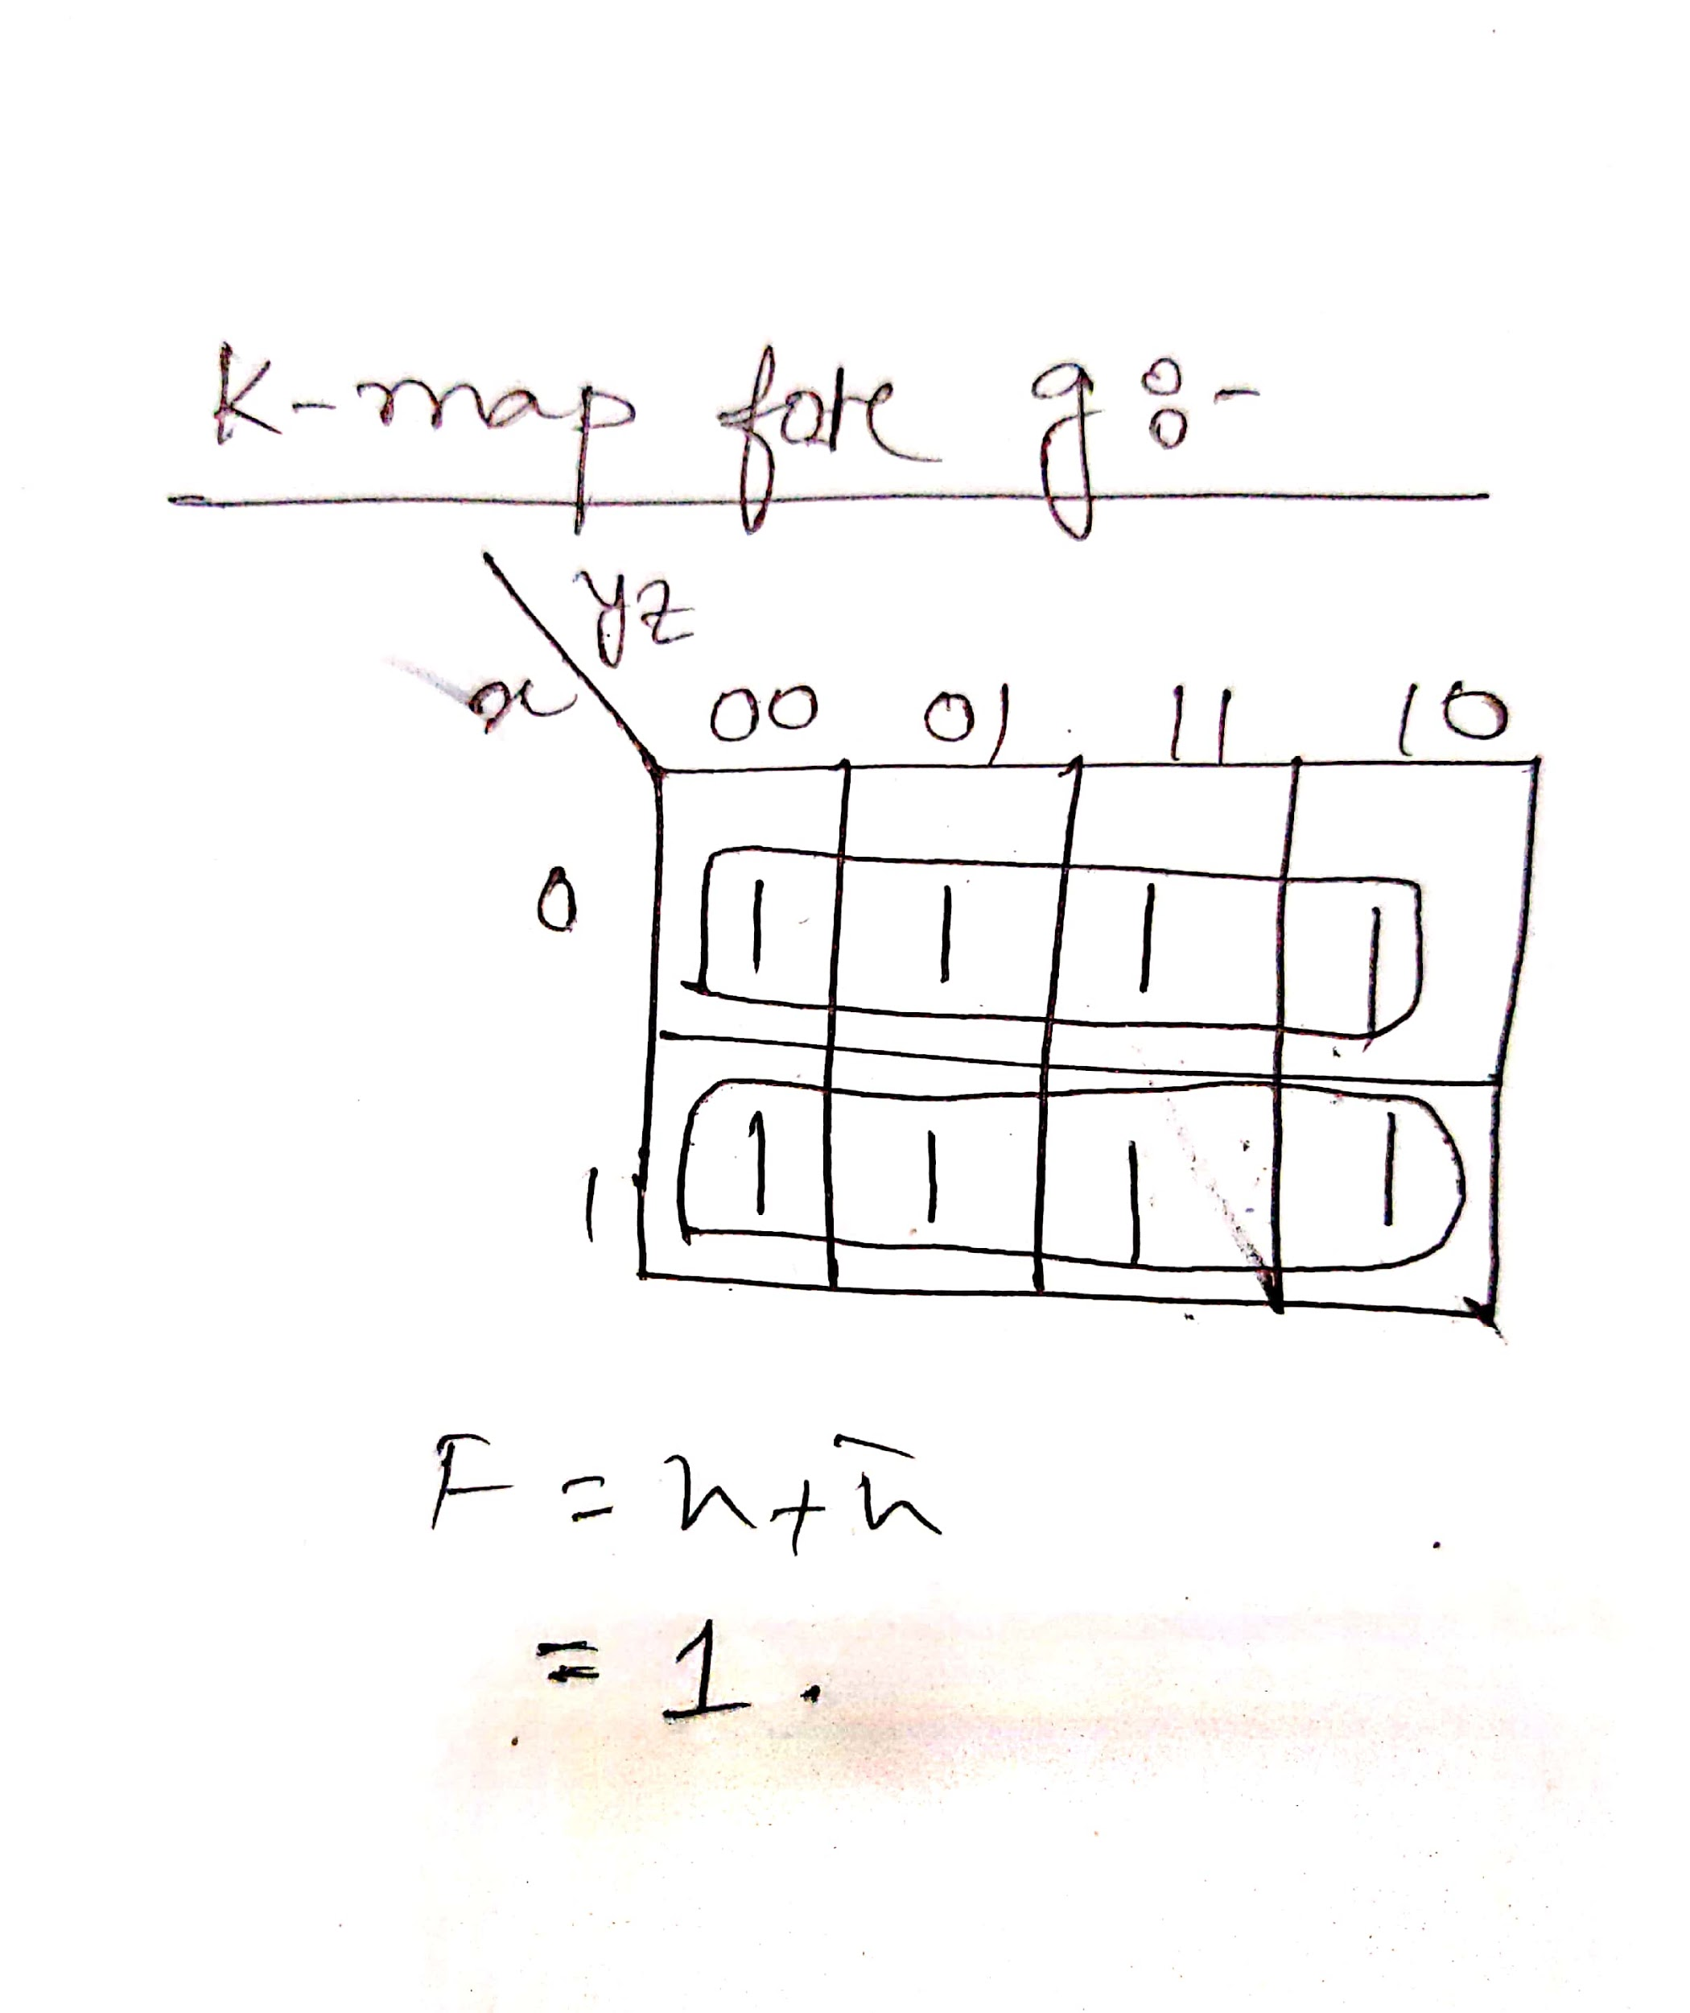  
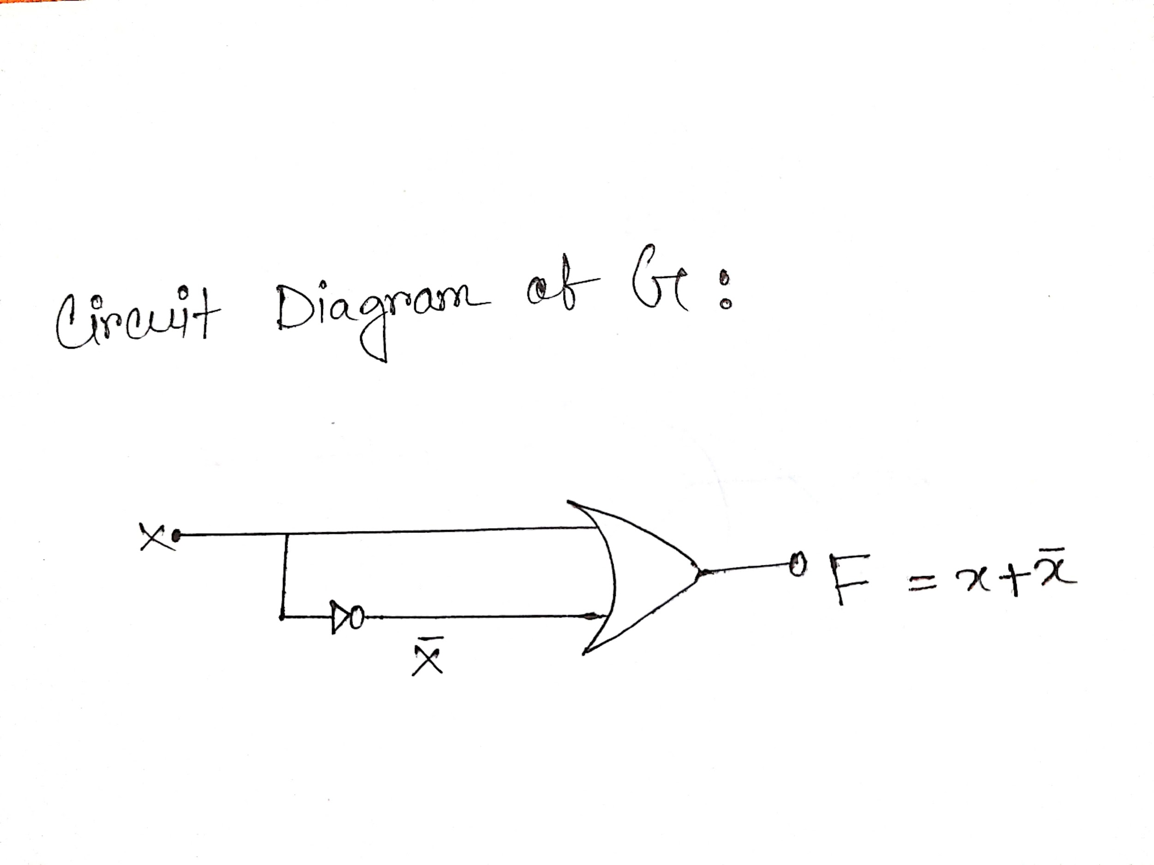

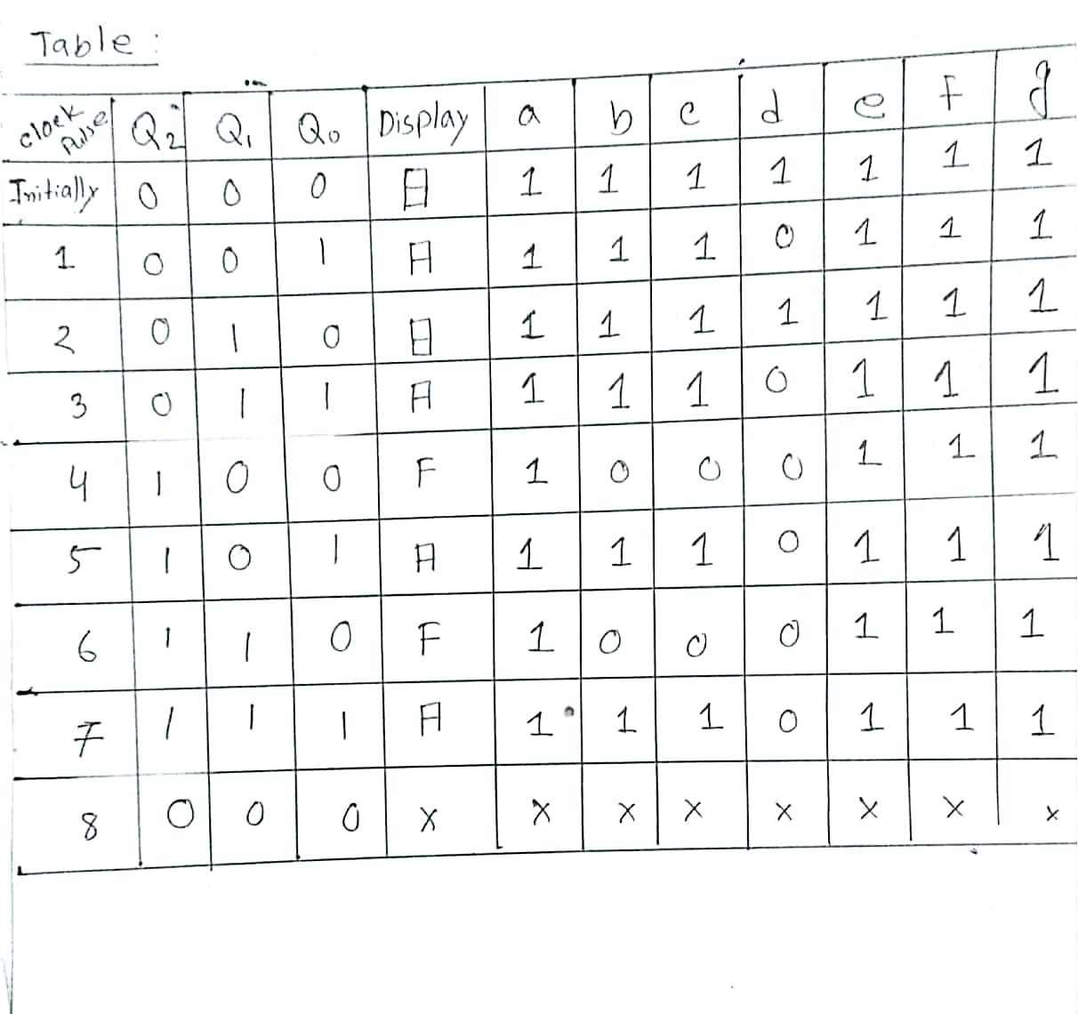  
 **Figure: Table 2  
  
  
  
  
  
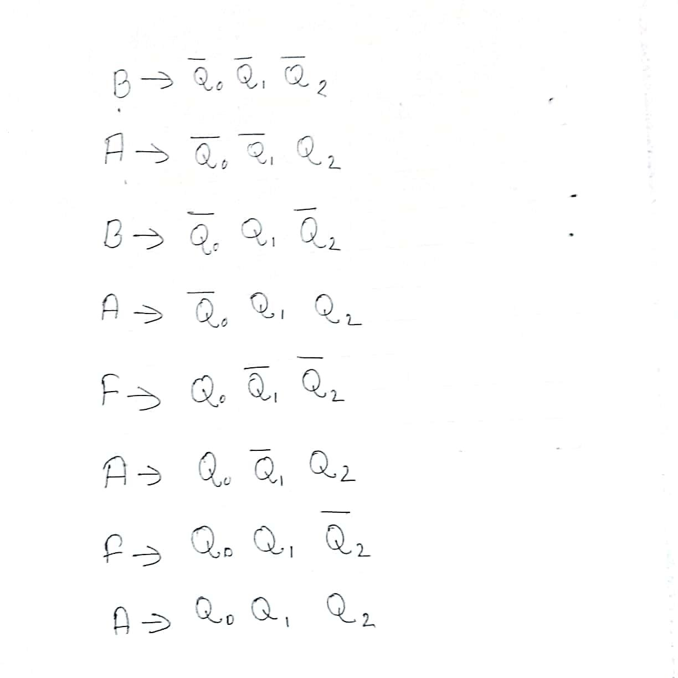  
  
  
  
  
  
  
  
  
  
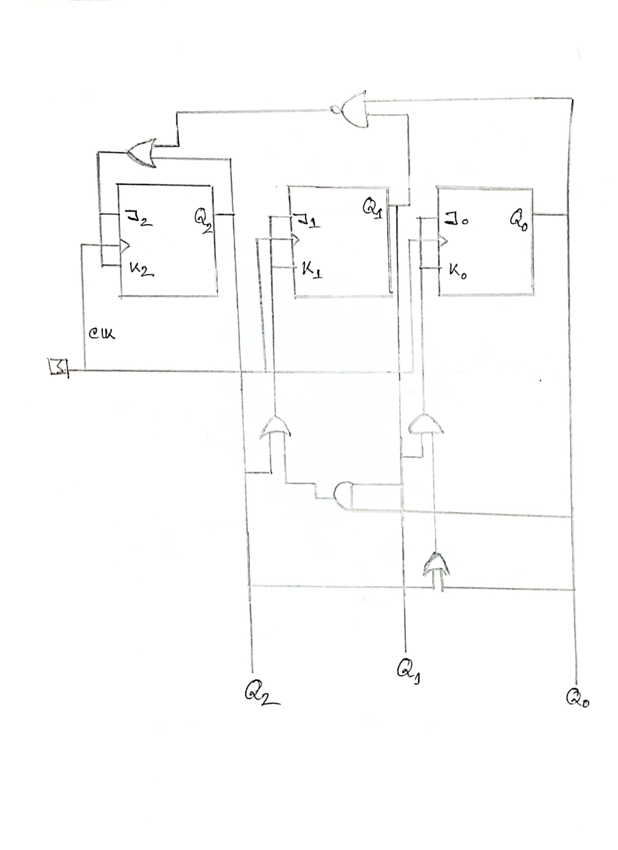  
Figure: Sequential circuit Diagram**

**Logisim**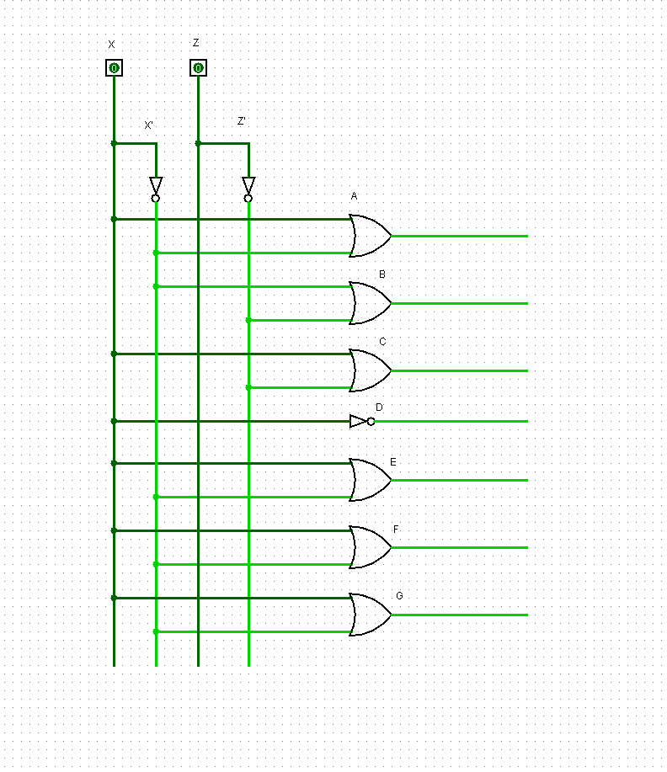  
**Figure A.1:** Circuit on logisim form k map

**Logisim without sequential circuit: On BABAFAFA  
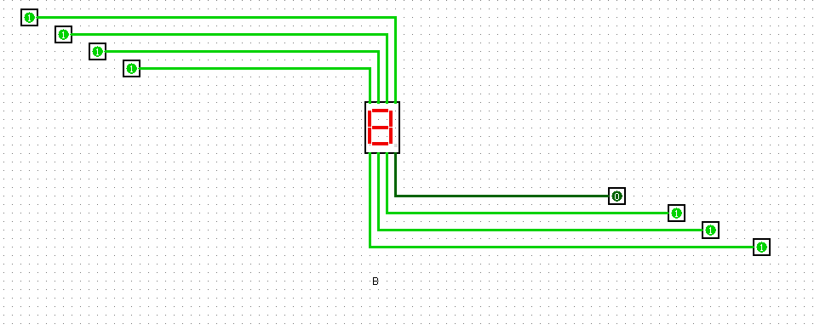  
 Figure B.1:B**

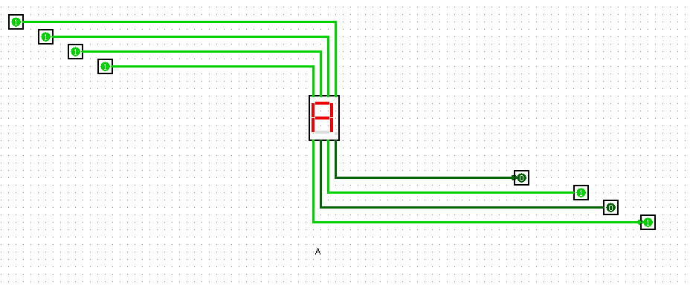

**Figure B.2: A**



**Figure B.3 : B**



**Figure B.4: A**

**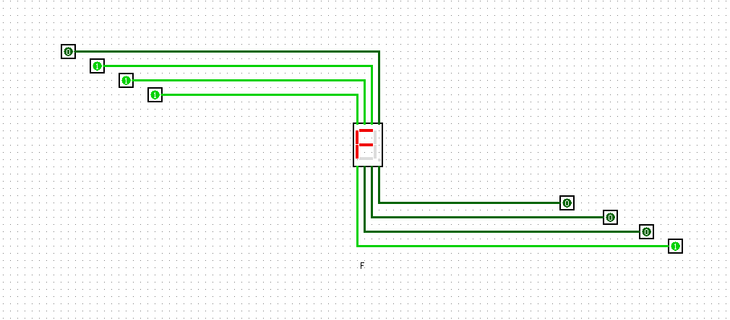  
Figure B.5: F**



**Figure B.6: A**



**Figure B.7: F**



**Figure B.8: A**

**Final output without using sequential circuit:  
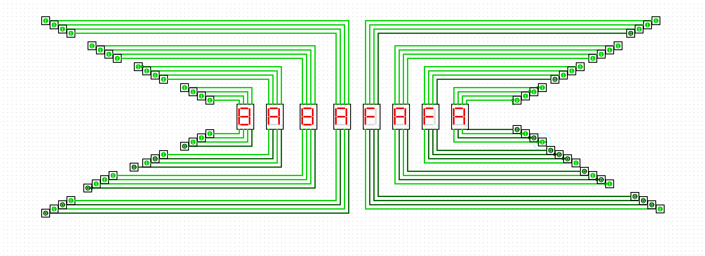**

**Figure B.9:** Final Output  
**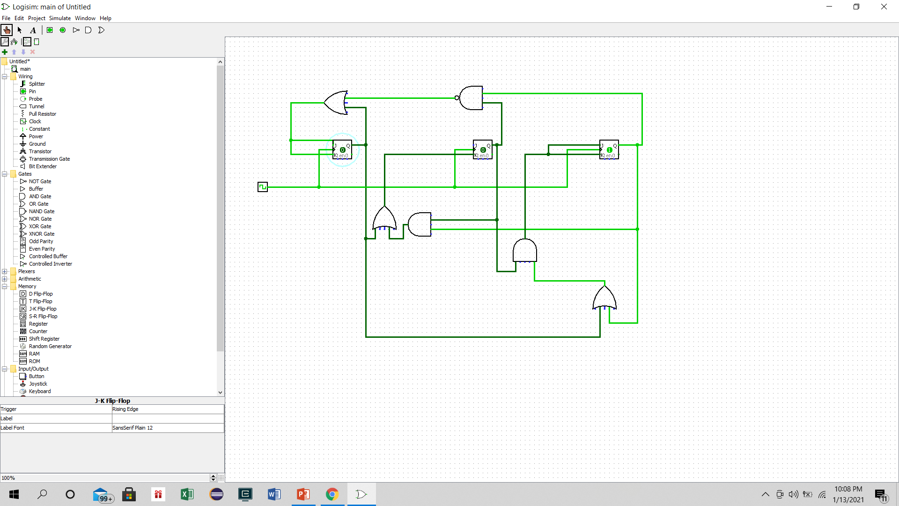  
Figure B.10:** Sequential Circuit

**Logisim Using Sequential Circuit:**

**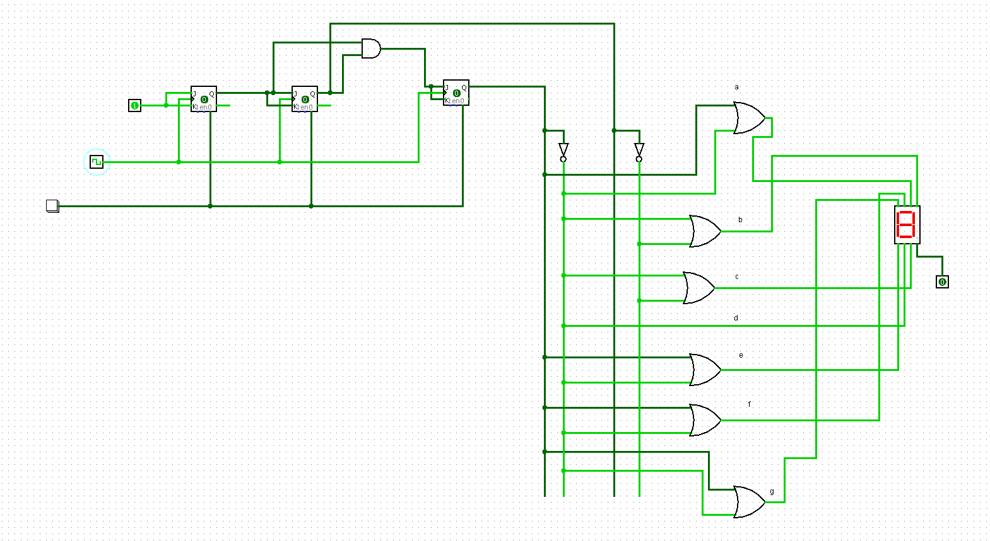  
Figure B.11: B** with Sequential circuit **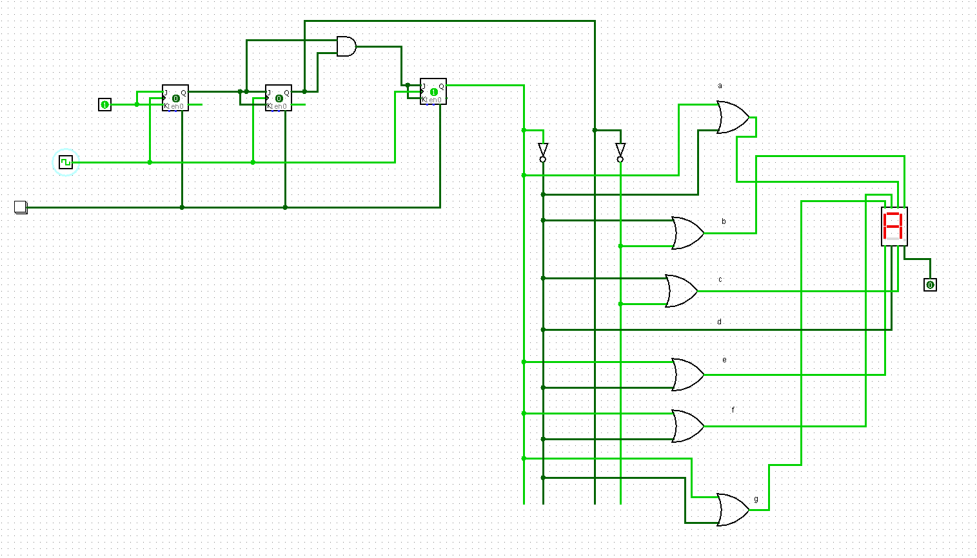  
Figure B.12: A** with Sequential Circuit

**  
Figure B.13: B** with Sequential circuit

**  
Figure B.14: A** with Sequential Circuit

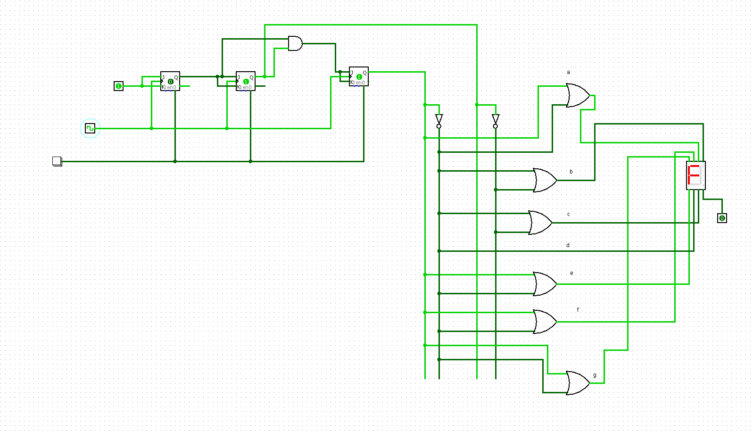  
**Figure B.15: F** with sequential circuit

**  
Figure B.16: A** with Sequential Circuit

  
**Figure B.17: F** with sequential circuit  
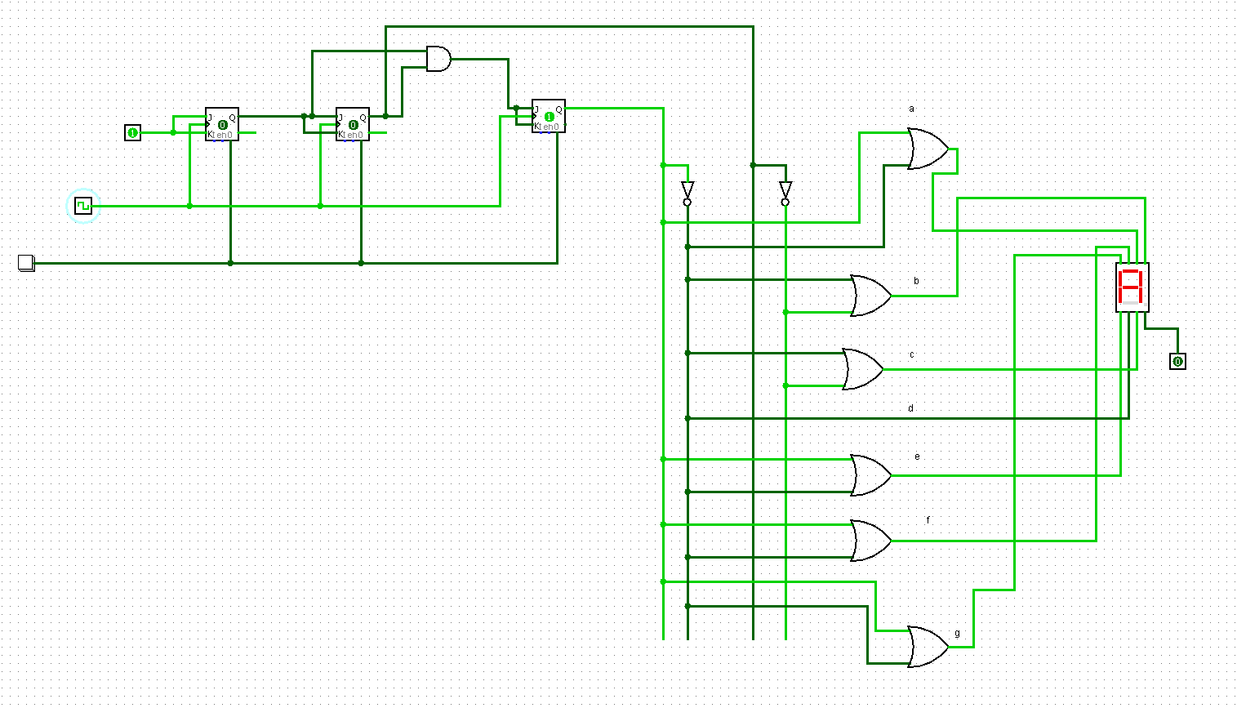

**Figure B.18: A** with Sequential Circuit

